John F. Sprunger, Rev.
July 12, 1925 – January 11, 1996
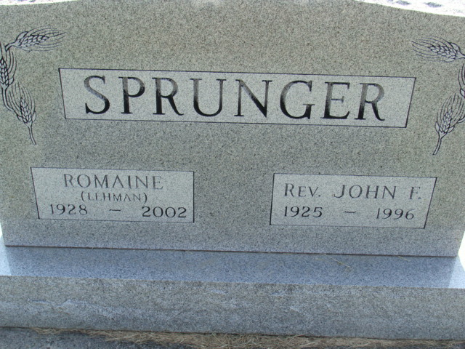
Photo by Alicia Kneuss

REV. JOHN F. SPRUNGER, 70, died Thursday at Adams County Memorial Hospital, Decatur. Born in Adams County, he was a former assistant pastor at First Mennonite Church, Berne. He pastored at several churches in Pennsylvania and Oklahoma. He was past president of Eastern District Mennonite Conference and served as a pastoral counselor in Pennsylvania.
Surviving are his wife, Romaine; three sons, the Rev. Tim of Hong Kong and Tom and the Rev. Robert, both of Berne; five brothers, Dr. Edgar, Donald, Eugene and Roy, all of Berne, and the Rev. Sam of Hammond; a sister, Betty Gurley of Ann Arbor, Mich.; and five grandchildren.
Services at 10:30 a.m. Monday at First Mennonite Church, Berne. Calling from 2 to 9 p.m. Sunday and from 8 to 9:15 a.m. Monday at Yager-Kirchhofer Funeral Home, Berne. Calling also one hour before services at the church. Burial in M.R.E Cemetery, Berne. Memorials to Mennonite Overseas Missions.

Journal Gazette, The (Allen County, Indiana)
Friday, January 12, 1996
**

Indiana, U.S., Death Certificates, 1899-2017

Name John F Sprunger
Gender Male
Race White
Marital Status Married
Age 70
Birth Date 12 Jul 1925
Birth Place Adams County
Death Date 11 Jan 1996
Death Place Decatur, Adams, Indiana, USA
Death Registration Date 1996
Father Robert Sprunger
Mother Rhonda Liechty
Spouse Romaine Lehman
Informant Romaine Sprunger; wife; Berne, Indiana
Burial January 15, 1996; MRE Cemetery; Berne, Indiana

