Joel Sprunger
September 23, 1892 – April 20, 1974

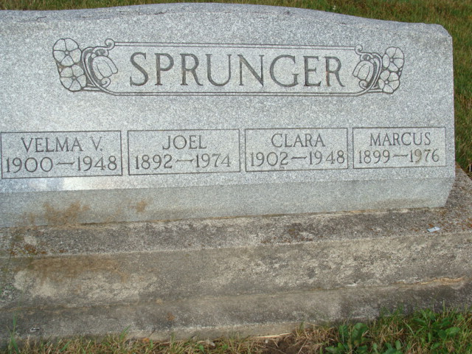
Photo by Alicia Kneuss

Joel Sprunger dies Saturday, funeral today
Services were held this afternoon at First Mennonite church, for Joel Sprunger, 81, a retired farmer who died at 9 a.m. Saturday. Rev. Gordon Neuenschwander and Rev. John W. Sprunger officiated at the service and burial was in the M.R.E. cemetery. The Yager Funeral home had charge of the service.
Mr. Sprunger died at the home of his son, Forrest Sprunger northeast of Berne where he resided and death was attributed to a heart attack. He had been ill since Christmas.
Born on the same farm where he died, Mr. Sprunger was the son of Ulrich and Anna Liechty Sprunger. He was born Sept. 23, 1892. He was married to Velma Verl Nichols who preceded in death. He was a lifelong resident of this community and a member of the First Mennonite church.
Surviving are the son; two daughters, Mrs. Harold (Ilva) Billington, Linn Grove and Mrs. Wilbert (Dorothy) Lehman, Berne; 15 grandchildren and five great-grandchildren; two brothers, Oscar and Marcus Sprunger and a sister, Mrs. Elam (Frieda) Steiner, all of Berne.
A son, Ray, two brothers, Eldon and Walter Sprunger, and a sister, Dora, preceded in death.

Lot 22 Sec. 2-4th ADD
Death date April 20, 1974; Burial Date April 22, 1974
Berne (IN) Public Library Heritage Room
1973-1984 MRE Obit Book, image 53

