Jodi Lyn Sprunger
February 1, 1969 – March 16, 1989
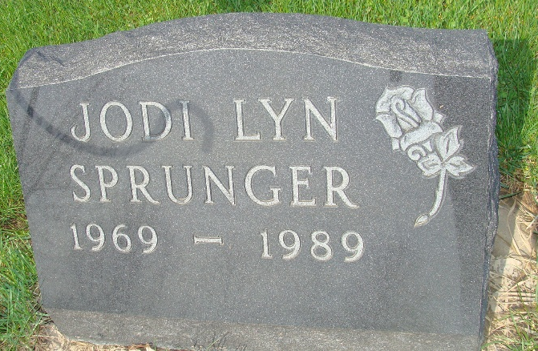
Photo by Alicia Kneuss

Ohio, U.S., Death Records, 1908-1932, 1938-2022

Name Jodi L Sprunger
Gender Female
Race White
Marital Status Not married (Married)
Death Age 20
Birth Date 1 Feb 1969
Birth Place Michigan, USA
Residence Place Adams, Indiana, USA
Death Date 16 Mar 1989
Death Place Mercer, Ohio, USA
Death Hospital Other/Other
Industry Homemaker, Student, Unemployed Volunteer
Occupation Student
Education 3 Years College
Filing Date 22 Mar 1989
Father Sprunger
Certificate Number 021761
Inquest Hospital Public - Other
Inquest Questions Place of Injury: Unspecified Place; Injury At Work?: No; Injury in Ohio?: Yes; Referred to Coroner?: Referred to Coroner; Certifier: Coroner; Autopsy Performed?: No Autopsy Performed
**

U.S., Family History Books

Name Jodi Lyn Sprunger
Birth Date 1 Feb 1969
Birth Place Grand Rapids, Michigan
Father Duane Marvin Sprunger
Mother June Sprunger
Title The Sprunger Family, 1757-1972: in Three Parts From Manuscripts, p. 101
7th Gen. Duane Marvin Sprunger b. April 1, 1949 Decatur, Ind., son of Marvin Lee & Margaret Pearl Parr Sprunger, married June 14, 1968, Berne, Ind. June Sprunger born May 2, 1948, Decatur, Ind., a daughter of orison & Marian Liechty Sprunger.
Their children:
1. Jodi Lyn Sprunger b. Feb. 1, 1969, Grand Rapids, Mich.
2. Shannon Sprunger b. July 24, 1970, Bluffton, Wells Co., Ind.
3. Sprunger b. June 1972

