Jerry Allen Sprunger
January 16, 1938 – October 2, 2000

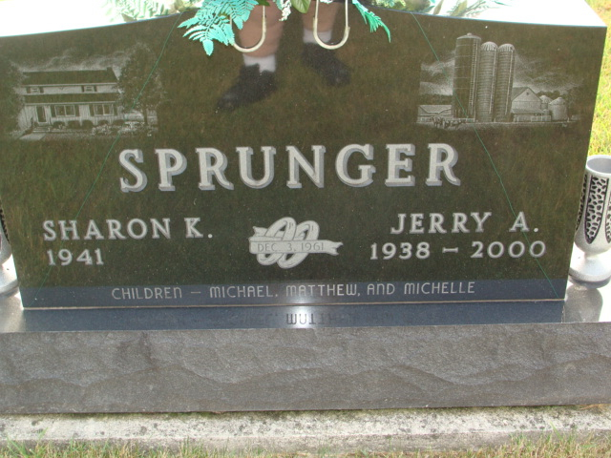
Photo by Alicia Kneuss

Jerry A. Sprunger, 62, of Berne, an area farmer, died Monday, Oct. 2, 2000, at home. The Adams County native was a member of First Mennonite Church and Monroe Township Advisory Board, a past supervisor of Adams County SWCD, and had served in the U.S. Army Reserve.
Surviving are his wife, Sharon; sons Michael of Berne and Matthew of Kaukauna, Wis.; a daughter, Michele Sprunger of Kaukauna; a brother, Ernest of Berne; a sister, Jane Steiner of Berne; and two grandchildren. He was preceded in death by sisters Shirley Fruechte and Josephine Meyer.
Services are 10:30 a.m. Friday at First Mennonite Church, Berne, with calling one hour before services. Calling is also from 5 to 8 p.m. today and also from noon to 8 p.m. Thursday at Yager-Kirchhofer Funeral Home, Berne. Burial will be at M.R.E. Cemetery. Memorials are to the Jerry A. Sprunger Educational Trust Fund for grandchildren or Swiss Village Endowment Fund. Information provided by Yager-Kirchhofer Funeral Home, Berne.

News-Sentinel, The (Allen County, Indiana)
Wednesday, October 4, 2000
**

Indiana, U.S., Death Certificates, 1899-2017

Name Jerry A. Sprunger
Gender Male
Race White
Marital Status Married
Age 62
Birth Date 16 Jan 1938
Birth Place Adams County
Death Date 2 Oct 2000
Death Place Berne, Adams, Indiana, USA
Death Registration Date 2000
Father Sylvan Sprunger
Mother Mary Lehman
Spouse Sharon Reinhart
Informant Sharon Sprunger; wife; Berne, Indiana
Burial October 6, 2000; MRE Cemetery; Berne, Indiana

