Jeanette Winona Sprunger
March 14, 1905 – January 8, 1999

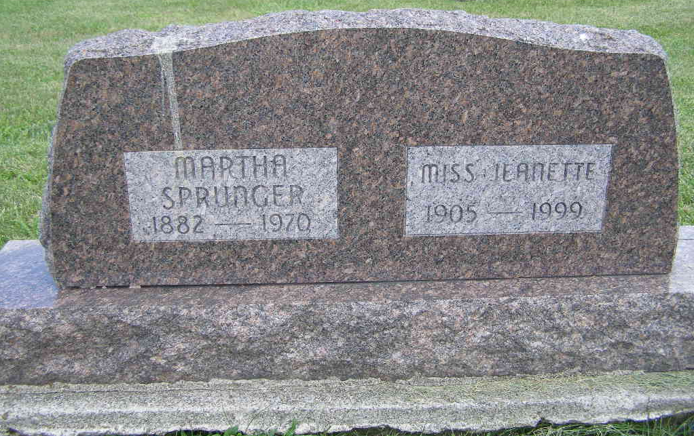
Photo by Shaunda Bedwell Opdycke
(back of parents Caroline & Nathan Sprunger stone)

Jeanette W. Sprunger, 93, of Berne, a member of First Missionary Church, died Friday, Jan. 8, 1999, at Adams County Memorial Hospital. The Adams County native was a retired elementary school teacher at Berne Elementary after 50 years. She was a member of Indiana State Teachers Association and National Education Association. She was an avid writer. Surviving is her sister, Lila Miller of Camp Hill, Pa. She was preceded in death by her brothers and sisters, Rolland, Clarence, Festus, Reuben, Irvin, Leslie, Vincent and Clyde Sprunger, and Dorothy Fuhrman. Services are 2 p.m. Sunday at Swiss Village Chapel, Berne, with calling an hour before services and from 3 to 7 p.m. today. Burial will be in M.R.E. Cemetery. Memorials are to the church's missions or Swiss Village. Information provided by Yager-Kirchhofer Funeral Home, Berne, 1-219-589-3101.

News-Sentinel, The (Allen County, Indiana)
Saturday, January 9, 1999
**

Indiana, U.S., Death Certificates, 1899-2017

Name Jeanette W. Sprunger
Gender Female
Race White
Marital Status Never
Age 93
Birth Date 14 Mar 1905
Birth Place Adams County
Death Date 8 Jan 1999
Death Place Decatur, Adams, Indiana, USA
Death Registration Date 1999
Father Nathan Sprunger
Mother Caroline Scheidegger
Informant Jerry Sprunger; nephew; Berne, Indiana
Burial January 10, 1999; MRE Cemetery; Berne, Indiana

