Jeanette Irene (Amstutz) Sprunger
December 8, 1922 – July 31, 2007

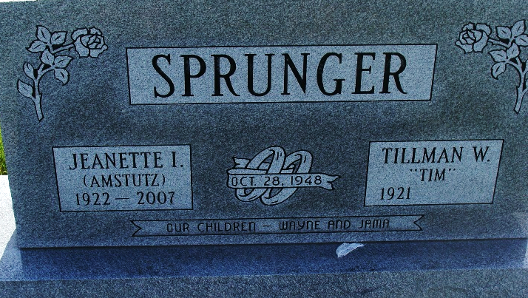
Photo by Alicia Kneuss

Jeanette I. Sprunger, 84 years old of Berne, Indiana, passed away on Tuesday, July 31, 2007 in the Swiss Village located in Berne. She was born on Saturday, December 8, 1922 in Adams County, Indiana the daughter of the late Carl Amstutz and the late Elma (Roth) Amstutz. She married Tillman Sprunger on October 28, 1948 in Berne, Indiana.
Jeanette graduated from Lutheran School of Nursing and attended Taylor University. She was employed as a nurse at Jay County Hospital, Caylor-Nickel Clinic, and local doctor's offices. She was a member of the First Missionary Church, Berne.
Surviving are her son, Wayne Sprunger of Berne, Indiana, daughter, Jama (Will) Mitchell of Granger, Indiana, brother, Dwight Amstutz of Berne, Indiana, brother, Marvin Amstutz, California, and two grandchildren.
Funeral services for Jeanette will be held at 2:00 p.m. Sunday, August 5, 2007 in the First Missionary Church with Rev. Kris McPherson and Rev. Max Haines officiating. Interment will follow in the M.R.E. Cemetery. Friends will be received from 4:00 p.m. to 8:00 p.m., Saturday, August 4 in the Yager-Kirchhofer Funeral Home and one hour prior to the service at the church on Sunday. ​
Preferred memorials are to First Missionary Church or the
Family Hospice of Northeast Indiana.
Yager-Kirchhofer Funeral Home, Adams County, Indiana
August 1, 2007

