Jay E. Sprunger
May 13, 1948 – August 30, 2016

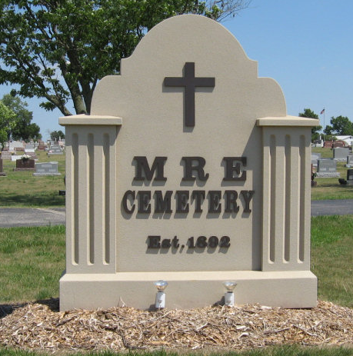
Photo by Tombstoner & Family

Jay E. Sprunger, 68, Oswago, Ill. passed away on Tuesday, August 30, 2016 in Yorkville. He was the son of Melvin and Ethelyn Burnett Sprunger born on May 13, 1948 in Adams County, IN.
Jay was a graduate of Berne High School and attended Ball State University majoring in elementary education. He started teaching in Monticello, IN. and later moved to southern Indiana along the Ohio River and became an elementary principal in Switzerland County. He relocated to northern Illinois and semi-retired working as a substitute teacher in Aurora. Jay enjoyed attending plays, concerts, soccer, football, and basketball events at the area small colleges.
Surviving are two brothers; Gary (Marge) Sprunger of Lafayette, Lew (Sandy) Sprunger of Berne and a brother-in-law, Tom Newman of Fort Wayne. Also surviving are many nephews and nieces.
Preceding in death are his parents and a sister Linda Newman.
Funeral services are Monday, September 5, 2016 at 1:00 pm with visitation from 11:00 am to time of services. Officiating is Pastor James Langham. Burial is in the MRE Cemetery, Berne.
Yager-Kirchhofer Funeral Home, Adams County, Indiana
August 31, 2016

