Janet Sprunger
January 16, 1945 – January 16, 1945

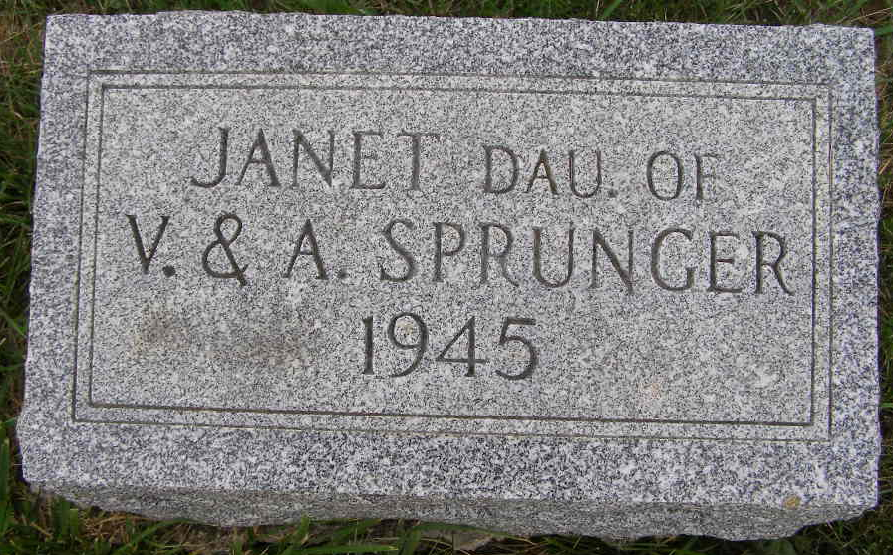
Photo by Shaunda Bedwell Opdycke

Janet Sprunger
in the Indiana, U.S., Death Certificates, 1899-2017

Name Janet Sprunger
Gender Female
Race White
Marital Status Single
Age 10 hours
Birth Date 16 Jan 1945
Birth Place Decatur, Adams, Indiana
Death Date 16 Jan 1945; premature
Death Place Decatur, Adams, Indiana, USA
Death Registration Date 1945
Father Victor P Sprunger
Mother Baumgartner
Informant Victor P. Sprunger
Burial January 17, 1945; MRE Cemetery; Berne, Indiana

