James Haecker Sprunger
November 28, 1928 – April 9, 1957

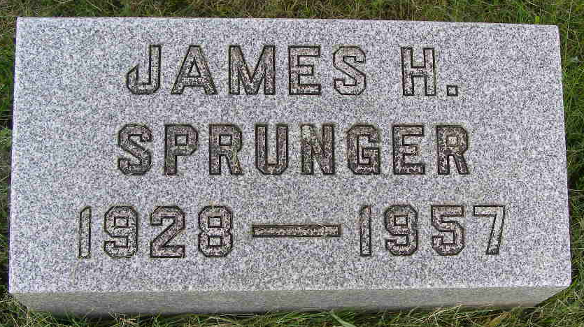
Photo by Shaunda Bedwell Opdycke

Berne Youth Found Dead At Bloomington
James H. Sprunger Found Dead Today

BLOOMINGTON, Ind. (UP) - James H. Sprunger, 28, student editor of the Indiana University Daily Student, was found dead lying across his bicycle Tuesday. The body was sprawled across the bike in an alley between the campus and his rooming house.
Sprunger, a native of Berne, Ind., used the bicycle to commute from his rooming house to the campus. Authorities said he apparently was the victim of a "seizure." Coroner Neil Baxter was investigating the death.
Sprunger was graduate journalism student at the university. His mother, Mrs. Naomi H. (rest is missing)

Adams County (IN) Historical Museum
1955 Mar-April 1958 Scrapbook, Image 98
Handwritten-Tues. April 9, 1957
**

Funeral Friday For James H. Sprunger
Death Is Attributed To Brain Concussion

Funeral services will be held at 2 o'clock Friday afternoon at the First Mennonite Church in Berne for James H. Sprunger, 28, of Berne, who collapsed and died Tuesday morning while riding his bicycle to the campus in Bloomington where he was a post graduate student in journalism at Indiana University.
Dr. Neil Baxter, Monroe County Coroner, attributed death to a brain concussion suffered when Sprunger fell from his bicycle. Baxter said the young Berne man apparently fainted while riding to the campus, suffering the concussion as he fell to the ground.
An Indiana University official said Sprunger reportedly had been having "periods of blackouts" for several months. He had been appointed editor of the Indiana Daily Student only two weeks ago.
The young man was born in Fort Wayne and had resided in Berne since 1945. He graduated from the Berne High School and served in the Army from 1952 to 1954.
His father, Clifton H. Sprunger, editor of the Berne Witness, died five years ago. Surviving are the mother and one sister, Barbara Ann Sprunger, also a post graduate student at I.U.
The body was brought to the Yager Funeral Home at Berne today. The Rev. Olin H. Krehbiel will officiate at the services Friday, and burial will be in the MRE Cemetery at Berne.

Adams County (IN) Historical Museum
1955 Mar-April 1958 Scrapbook, Image 100
Handwritten-Wed. April 10, 1957
**

Indiana, U.S., Death Certificates, 1899-2017

Name James Haecker Sprunger
Gender Male
Race White
Age 28
Marital Status Never Married (Single)
Birth Date 28 Nov 1928
Birth Place Ft. Wayne, Indiana
Death Date 9 Apr 1957
Death Place Bloomington, Monroe, Indiana, USA
Death Registration Date 1957
Father Clifton H. Sprunger
Mother Naomi Haecker
Informant: Barbara Ann Sprunger; sister; Berne, Indiana
Burial: April 12, 1957; MRE Cemetery; Berne, Indiana

