James E. Sprunger
March 9, 1923 – June 4, 1979

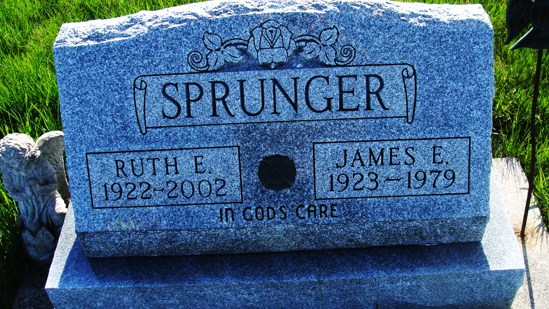
Photo by Alicia Kneuss

Indiana, U.S., Birth Certificates, 1907-1944

Name James Sprunger
Gender Male
Birth Date 9 Mar 1923
Birth Place Hartford, Adams, Indiana, USA
Father Herbert R Sprunger; age 34
Mother Elma Neuenschwander; age 31; 4th child; all living
Certificate Number 16779
Roll number 40474_357307
Volume Range 31 - 35
**

Indiana, U.S., Death Certificates, 1899-2017

Name James E Sprunger
Gender Male
Race White
Marital Status Married
Age 56
Birth Date 9 Mar 1979 [sic]
Birth Place Indiana
Death Date 4 Jun 1979
Death Place Berne, Adams, Indiana, USA
Death Registration Date 1979
Father Herbert Sprunger
Mother Elma Neuenschwander
Spouse Ruth Montgomery
Informant Ruth Sprunger; Berne, Indiana
Burial June 6, 1979; MRE Cemetery; Berne, Indiana

