Jerry Steven Sprunger
April 28, 1941 – November 10, 1983

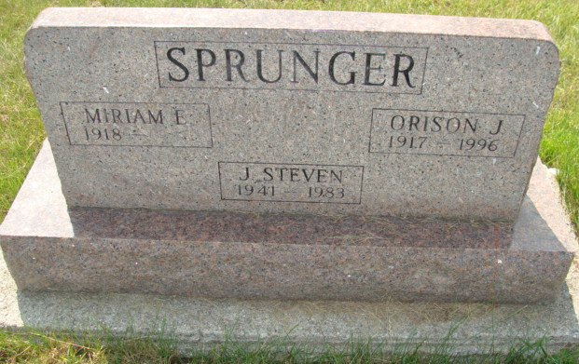
Photo by Alicia Kneuss

Jerry Steven Sprunger
in the Indiana, U.S., Birth Certificates, 1907-1944

Name Jerry Steven Sprunger
Gender Male
Birth Date 28 Apr 1941
Birth Place Berne, Adams, Indiana, USA
Father Orison Sprunger; age 23
Mother Miriam Liechty; age 22; 1st child
Registration Year 1941
Certificate Number 15484
Roll number 60871.IDX.002_I1415085
Volume Range 30-34
**

U.S., Social Security Applications and Claims Index, 1936-2007

Name Jerry Steven Sprunger
[Jerry Sprunger]
Gender Male
Race White
Birth Date 28 Apr 1941
Birth Place Berne Adams, Indiana
Death Date Nov 1983
Father Orison J Sprunger
Mother Miriam E Liechty
SSN xxx
Notes Jun 1956: Name listed as JERRY STEVEN SPRUNGER; 29 Dec 1987: Name listed as JERRY SPRUNGER

