Isaac Sprunger
December 22, 1859 – March 26, 1931

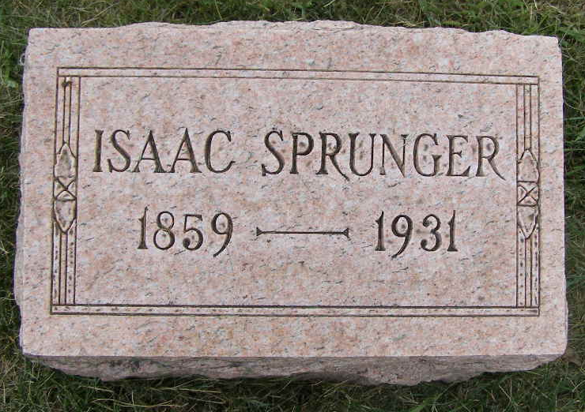
Photo by Shaunda Bedwell Opdycke

Indiana, U.S., Death Certificates, 1899-2017

Name Isaac Sprunger
Gender Male
Race White
Marital Status Married
Age 72
Birth Date 22 Dec 1859
Birth Place Indiana
Death Date 26 Mar 1931
Death Place Decatur, Adams, Indiana, USA
Death Registration Date 1931
Father David Sprunger
Mother Barbara Lehman
Spouse Diana
Informant Nelson Sprunger; Fort Wayne, Indiana
Burial March 28, 1931; MRE Cemetery

