Irvin Theophil Sprunger
July 12, 1898 – May 5, 1994

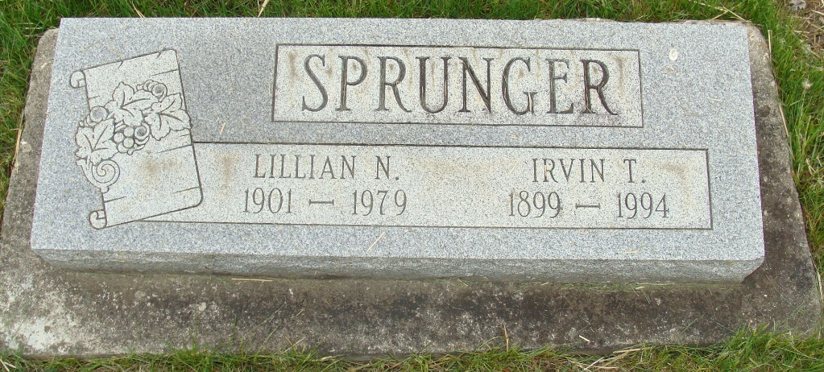
Photo by Alicia Kneuss

Indiana, U.S., Death Certificates, 1899-2017

Name Irvin T Sprunger
Gender Male
Race White
Marital Status Widowed
Age 94
Birth Date 12 Jul 1899
Birth Place Adams County, Indiana
Death Date 5 May 1994
Death Place Decatur, Adams, Indiana, USA
Death Registration Date 1994
Father Nathan Sprunger
Mother Caroline Scheidegger
Informant Julia McCullough; daughter; Geneva, Indiana
Burial May 9, 1994; MRE Cemetery; Berne, Indiana

