Irvin E. Sprunger
February 18, 1912 – January 16, 1990

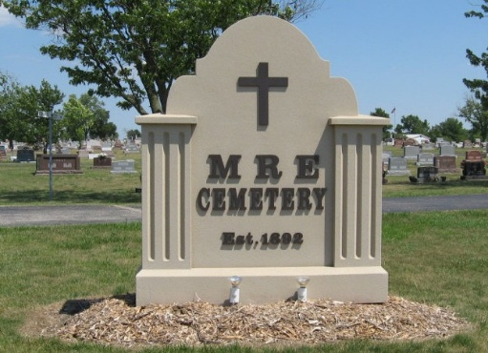
Photo by Tombstoner & Family

Indiana, U.S., Death Certificates, 1899-2017

Name Irvin E Sprunger
Gender Male
Race White
Marital Status Married
Age 77
Birth Date 18 Feb 1912
Birth Place Adams County, Indiana
Death Date 16 Jan 1990
Death Place Portland, Jay, Indiana, USA
Death Registration Date 1990
Father Alfred Sprunger
Mother Robertine Liechty
Spouse Norma Agler
Informant Norma Sprunger; wife; Berne, Indiana
Burial January 18, 1990; MRE Cemetery; Berne, Indiana

