Irena (Liechty) Sprunger
October 1, 1918 – May 2, 2013

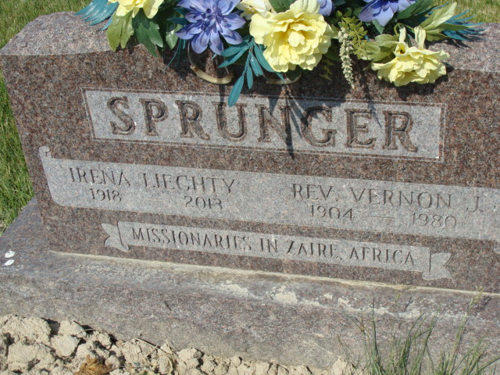
Photo by Alicia Kneuss

Irena Liechty Sprunger, 94, Berne passed away on May 2, 2013. The third of twelve children, Irena was born October 1, 1918 to the late Amos and Della (Nussbaum) Liechty. Following her graduation from Monroe High School in 1936, she worked at Berne Overall and Shirt and at Economy Printing where she ran one of four Linotypes. She was a member of the First Mennonite Church in Berne.
Hearing the call to be a missionary in Africa, Irena attended Grace Bible Institute in Omaha, Nebraska, graduating in 1949, and earned a Bachelor of Arts degree from Goshen College in 1952. Additional study was in Brussells where she studied French for a year. In 1953 she arrived in the Belgian Congo where she served as director of the primary school and School for Girls for the Congo Inland Mission (now Africa Inter-Mennonite Mission) in Charlesville. Following the evacuation of all Congo missionaries to Angola in 1960, Irena returned to the capital city of Leopoldville to manage the large printing press that supported all Protestant missions in Congo.
In June 22, 1962 Irena married missionary colleague Vernon Sprunger in Berne. They returned to Zaire and worked for nine more years before retiring in 1972 in Berne. Following Vernon's death in 1980, Irena was invited to join the pastoral staff at First Mennonite Church of Berne and served for thirteen years as Assistant to the Minister of Visitation until she retired in 1994.
In addition to her husband, she was preceded in death by five sisters; Vera Gerber, Marcella Scholl, Esther Neuenchwander, and infants Justine and Ernestine; four brothers, Grover, Irvin, Ernie, and Amos, and one grandson.
She is survived by two sisters; Leona (Phil) Neuenschwander, and Grace Herman. In addition, she is survived by four step-children; Charles (Geraldine) Sprunger of Trappe, PA., Wilmer (Kenlyn) Sprunger of Berne, IN., Jeannette (Thomas) Bechtel of Goshen, IN and Shirley (Vernon) King of Boiling Springs, PA., thirteen grandchildren and nine great-grandchildren.
Funeral services Friday, May 10, 2013 at 10:30 am at the First Mennonite Church with visitation 1 hour prior to services. Visitation also Thursday from 5 to 8:30 pm at Swiss Village. Officiating is Pastor Jerry A. Flueckiger.
Preferred gifts can be designated for Africa Inter-Mennonite Mission. P.O Box 744, Goshen, IN 46527 0744. Burial is in the M.R.E. Cemetery, Berne.

Yager-Kirchhofer Funeral Home, Adams County, Indiana

