Ira H. Sprunger
January 10, 1890 – January 24, 1947

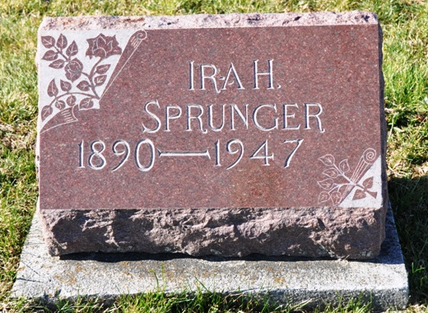
Photo by Deb Curry

Ira H. Sprunger, 57, linotype operator at the Berne Witness, died at 7:30 a.m. today (January 24) in the Lutheran Hospital, Fort Wayne, of a heart ailment. He had been ill since November 24. Surviving are his wife, Anna; a daughter, Miss Elizabeth Jeanette Sprunger, a nurse at the Swedish Covenant Hospital, Chicago; a stepdaughter, Miss Ardythe May Luginbill, at home; a brother, Otto Sprunger, Bluffton, and eight sisters, the Misses Mary Ann, Hannah, Milka, Rose and Alina Sprunger, Mrs. Gideon Sprunger and Mrs. Noah Habegger, all of Berne, and Mrs. J. C. Kaufman, Whitewater, Kansas. The body, returned here to the Yager Mortuary, will be taken to the Ely Luginbill residence Saturday morning. Funeral services will be conducted at 2 p.m. Sunday in the First Mennonite Church, the Rev. Owen Crabill officiating. Burial will be in the MRE Cemetery.

Fort Wayne Journal Gazette (Adams County, Indiana)
January 25, 1947
**

IRA H. SPRUNGER SUCCUMBS TODAY; ILL FOR TWO MONTHS
Funeral Sunday for Berne Witness Linotype Operator

Ira H. Sprunger, 57, linotype operator at the Berne Witness Company for the last 17 years, died this morning at about 7:20 o'clock at the Lutheran Hospital in Fort Wayne, following an illness of two months. Death is believed to be due to heart disease and complications. An autopsy was to be made sometime today to learn the exact cause of death, but he had suffered from heart trouble.
Mr. Sprunger became seriously ill on November 24, just two months ago, and on November 29, he was taken to the Adams County Memorial Hospital. He failed to respond to treatment there and was then taken to the Lutheran Hospital at Fort Wayne. His death came more or less unexpectedly. It was known that his condition was serious, but he had been reported resting more easily the last few days. None of the members of the family were at his bedside when death came, and his wife did not know that he had passed away until notified by telephone this morning. He died in his sleep, according to hospital staff. One of the nurses talked to him about 4 o'clock this morning while he was awake briefly.
Mr. Sprunger, while not seriously ill until November, had not been in good health for some time. He suffered from high blood pressure and other complications. He had, however, been employed steadily until his fatal illness, except for some rest periods last summer, which had been ordered by the doctor.
Mr. Sprunger was born north of Berne, on what is now known as the David J. Schwartz farm, on January 10, 1890. He was the son of Frederick and Katherine Sprunger. He farmed the home place after his father's death (missing). He attended Bluffton College for one year and spent nine months at Camp Taylor, Kentucky, during World War I. (Missing) He was also employed with Victor Bagley for some time, with E.H. Habegger in the construction of silos, with the A.J. Moser plumbing (missing)
Surviving are his wife, Anna; a daughter, Miss Elizabeth Jeanette Sprunger, a nurse at the Swedish Covenant Hospital, Chicago, and a step-daughter, Miss Ardythe Mae Luginbill, at home. The following sisters and brothers survive: Mary Ann, Mrs. Gideon Sprunger, Hannah, Mrs. Noah Habegger, Milka, all of Berne; Otto Sprunger, Bluffton; Mrs. J. C. Kaufman, Whitewater, Kansas; Rose and Alina Sprunger, both of Berne.
A brother, D.J. Sprunger, preceded in death in December 1945, and two brothers died in infancy.
Mr. Sprunger was a member of the Mennonite Church. He was a member of the Mennonite Men's Chorus for several years.
Mr. and Mrs. Sprunger resided with her parents, Mr. and Mrs. E.A. Luginbill at 405 West Wayer Street. The body will be removed Saturday morning from the Yager Mortuary to the Ely Luginbill home, where it may be viewed.
Funeral services will be held at 2:00 p.m. Sunday at the First Mennonite Church, the Rev. Olin Crabill officiating. A short service will be held at the residence at 1:30. Burial will be in the M.R.E. Cemetery.

Adams County, Indiana Historical Museum
Scrapbook "1947Jan-May", image 19
Handwritten-Fri. Jan. 24, 1947

