Infant son Sprunger
June 5, 1924 – June 5, 1924

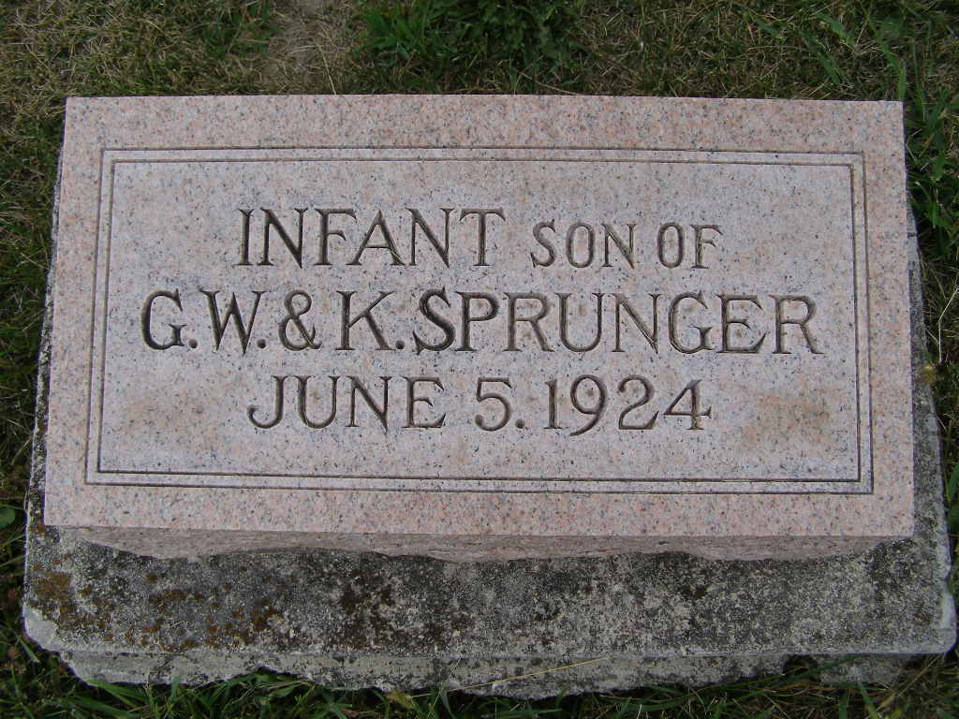
Photo by Shaunda Bedwell Opdycke

No further information found at this time.

