Ida Irene (Zuercher) Sprunger
August 19, 1927 – April 7, 2009

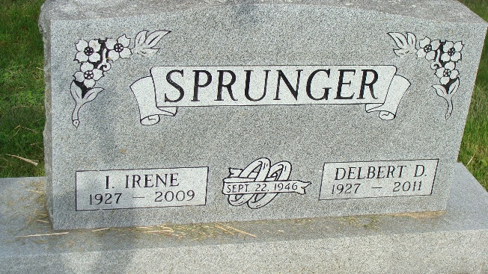
Photo by Alicia Kneuss

Ida Irene Sprunger-Zuercher, 81, of Decatur, Indiana and formerly of Berne, Indiana passed away Tuesday, April 7, 2009 at the Woodcrest Retirement Community in Decatur, Indiana. Ida Irene was born on August 19, 1927 in Berne, Indiana the daughter of Christian and Ida (Bachofen) Zuercher, both deceased, immigrants from Bern, Switzerland. She married Delbert Sprunger on September 22, 1946 in Berne, Indiana and he survives.
Ida Irene was active in community affairs, having served as a Girl Scout Leader, on the board of the South Adams Art Council, Executive Manager of the Berne Chamber of Commerce for three years, Secretary of the Mennonite Choral Society, member of the organizing board of the Adams County United Way, member of the organizing board of the Adams County Foundation, member of the Berne Swiss Days planning committee for fifteen years and headed this committee for three years, and was a member of the Berne Swiss Folklore Musical Group. Ida Irene and her husband also owned and operated the Musik Haus of Berne for thirty years.
Ida Irene is survived by her husband, Delbert Sprunger of Decatur, Indiana; a son, Erick Steven (Mary Jane) Sprunger of Sacramento, California; brother, Sylvan (Opal) Zuercher of Albuquerque, New Mexico; sister-in-law, Lucille Zuercher of Berne, Indiana; brother-in-law, Logan Sprunger of Berne, Indiana; sister in-law, Donna Mae Sprunger of Schererville, Indiana; and many nieces and nephews scattered in many states and Germany. Ida Irene was preceded in death by brothers, Walter Zuercher and Kurt Zuercher.
A memorial service will be held at 1:30 p.m. Saturday, April 11, 2009 in the First Mennonite Church in Berne with the Rev. Jerry Flueckiger, and the Rev. Harold Nussbaum officiating. Interment will be in the M.R.E. Cemetery of rural Berne. Family and friends will be received from 4:00 – 8:00 p.m. Friday, April 10, 2009 in the Yager-Kirchhofer Funeral Home in Berne.
Preferred memorials are to the Diabetes Association., the Heart Association, the Salvation Army, or Family Hospice of Northeast Indiana.

Yager-Kirchhofer Funeral Home, Adams County, Indiana

