Hulda (Stucky) Sprunger
January 7, 1893 – August 11, 1922

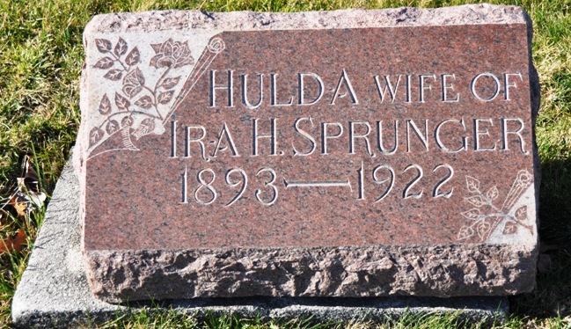
Photo by Deb Curry

MRS. IRA SPRUNGER DIED AT HER HOME IN BERNE LAST FRIDAY

Mrs. Ira Sprunger, age 29 years, died at her home in Berne last Friday afternoon following an illness of tubercular meningitis. Funeral services were held yesterday afternoon from the Mennonite Church in Berne. She is survived by her husband, a four months old daughter, one brother, three half-brothers and one half sister.

Decatur Daily Democrat, Adams County, Indiana
Tuesday, August 15, 1922
**

Indiana, U.S., Death Certificates, 1899-2017

Name Hulda Sprunger
[Hulda Stucky]
Gender Female
Race White
Age 29
Marital Status Married
Birth Date 7 Jan 1893
Birth Place Berne Indiana
Death Date 11 Aug 1922
Death Place Berne, Adams, Indiana, USA
Death Registration Date 1922
Father Jacob Stucky
Mother Elizabeth Lehman
Spouse Ira H. Sprunger
Informant: Ira Sprunger; Berne, Indiana
Burial: August 14, 1922; MRE Cemetery

