Howard R. Sprunger
February 10, 1899 – January 19, 1988

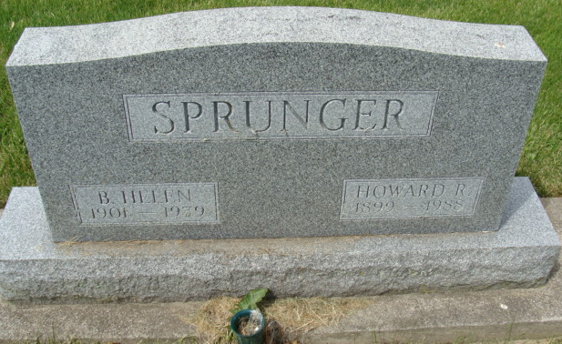
Photo by Alicia Kneuss

Howard R Sprunger
in the Indiana, U.S., Death Certificates, 1899-2017

Name Howard R Sprunger
Gender Male
Race White
Age 88
Marital Status Widowed
Birth Date 10 Feb 1899
Birth Place Adams County, Indiana
Death Date 14 Jan 1988
Death Place Portland, Jay, Indiana, USA
Death Registration Date 1988
Father Daniel Sprunger
Mother Elizabeth Lehman
Informant: Bruce W. Sprunger; son; Berne, Indiana
Burial: January 16, 1988; MRE Cemetery; Berne, Indiana

