Hilma Sprunger
May 29, 1897 – September 1, 1906

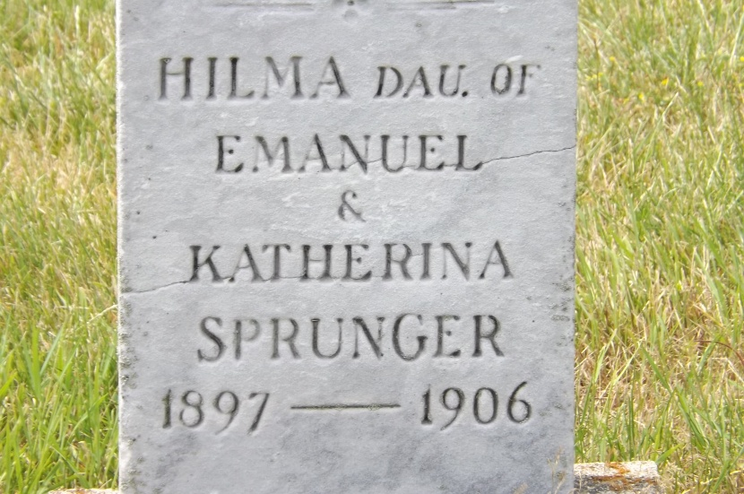
Photo by Jim Allen

Helena Sprunger
in the Indiana, U.S., Death Certificates, 1899-2017

Name Hilma Sprunger
Gender Female
Race White
Age 9
Birth Date 29 May 1897
Birth Place Monroe Tp Indiana
Death Date 1 Sep 1906
Death Place Monroe, Adams, Indiana, USA
Death Registration Date 1906
Father Emanuel Sprunger
Mother Katie Stauffer
Informant: Emanuel Sprunger; Berne, Indiana
Burial: September 3, 1906; MRE Cemetery

