Helen M. (Balsiger) Sprunger
February 4, 1917 – December 9, 2012

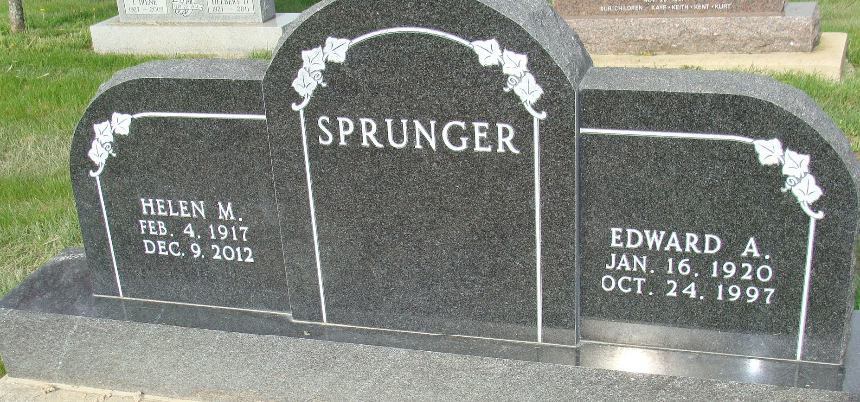
Photo by Alicia Kneuss

Helen M. Sprunger, 95, Berne, passed away Sunday, December 9, 2012 at Swiss Village. She was born to Christian and Alina (Burry) Balsiger on February 2, 1917 in Adams County. She married Edward A. Sprunger on June 11, 1941.
Helen was a member of the First Mennonite Church and was on the charter committee that composed the original church Swiss Pantry cookbook. Helen was a "Prayer Warrior" and knitted many afgans for missions. She and Edward spent many winters volunteering at Camp Gilead, Florida. Besides enjoying traveling, knitting, spending summers at the lake and gardening, she loved her family.
Helen is survived by her three daughters, Beth(Tom) Jones of Berne, Candy (Darrell) Shierling of Zionsville, In., and Barbara McDonald of Berne. Also 6 grandchldren; Jamie McDonald, Tom Jones,Jr., Tami Yoder, Taya Yoder, LeAnn Hardy, and Bret Shierling, 12 great-grandchildren.
Preceding in death are her parents, husband, brothers, Eldon and Milford Balsiger, sisters Gertrude Balsiger and Vera Lehman.
Funeral services are Wednesday, December 12 at 10:30am at the First Mennonite Church chapel with visitation 1 hour prior to services. Visitation also Tuesday from 4:00 pm to 8:00 pm at Yager-Kirchhofer Funeral Home. Officiating is Pastor Jerry A. Flueckiger. Burial at the MRE Cemetery, Berne
Preferred memorials to Mennonite Missions and/or Family Life Care.

Yager-Kirchhofer Funeral Home, Adams County, Indiana

