Hannah Sprunger
January 27, 1878 – June 9, 1958

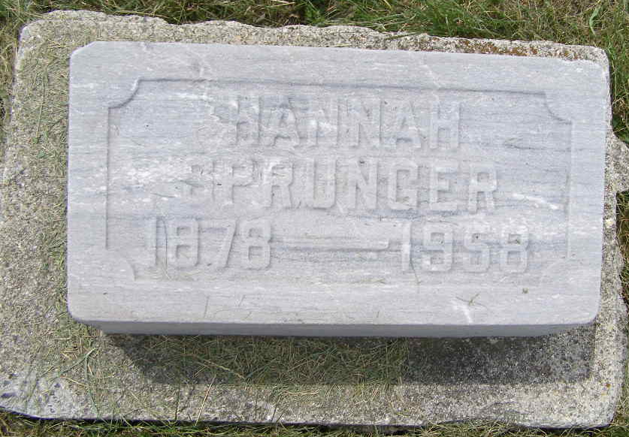
Photo by Shaunda Bedwell Opdycke

Indiana, U.S., Death Certificates, 1899-2011
Name: Hannah Sprunger
Gender: Female
Race: White
Age: 80
Marital status: Never Married (Single)
Birth Date: 27 Jan 1878
Birth Place: Indiana
Death Date: 9 Jun 1958
Death Place: Decatur, Adams, Indiana, USA
Father: Frederich Sprunger
Mother: Katherina Sprunger
Informant: None listed
Burial: June 12, 1958; MRE Cemetery; Berne, Indiana

