Grover William Sprunger
June 27, 1890 – October 24, 1965

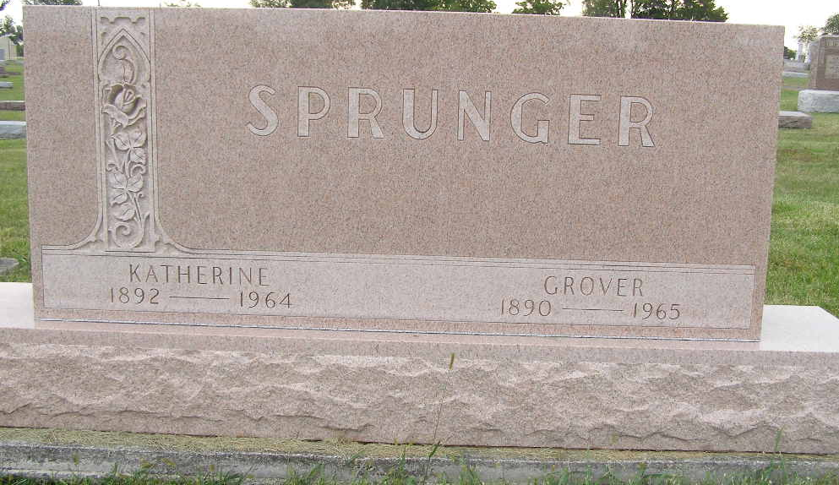
Photo by Shaunda Bedwell Opdycke

Indiana, U.S., Death Certificates, 1899-2017

Name Grover W Sprunger
Gender Male
Race White
Marital Status Widowed
Age 75
Birth Date 27 Jun 1890
Birth Place Indiana
Death Date 24 Oct 1965
Death Place Berne, Adams, Indiana, USA
Father Levi Sprunger
Mother Matilda Baumgartner
Informant Harold D. Sprunger, son
Burial 10/27/1965 M.R.E.
**

Indiana, U.S., Marriages, 1810-2001

Name Grover Sprunger
Gender Male
Race White
Age 27
Birth Date 29 Jun 1890
Birth Place Berne, Indiana
Marriage Date 15 Jun 1917
Marriage Place Indiana, United States
Residence Place Berne, Indiana
Father Levi Sprunger
Mother Matilda Baumgartner
Spouse Katherine Neuenschwander
Page 227
FHL Film Number 002321630

