Gordon Abraham Sprunger
March 3, 1907 – January 4, 1914

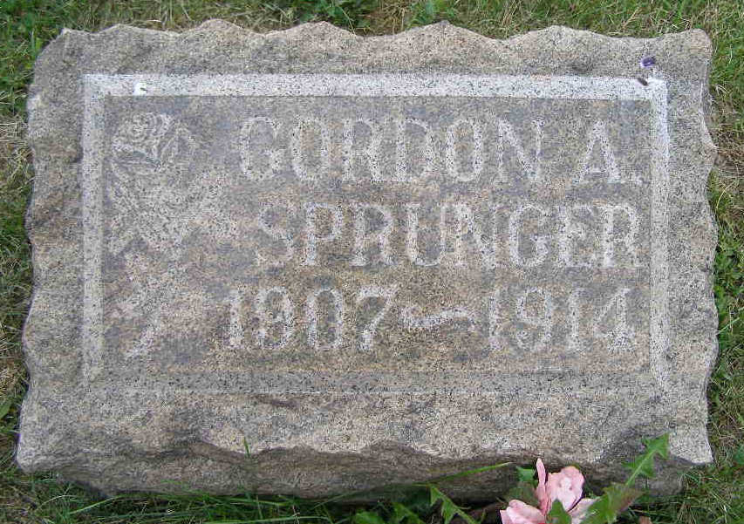
Photo by Shaunda Bedwell Opdycke

Indiana, U.S., Death Certificates, 1899-2017

Name Gordon Abraham Sprunger
Gender Male
Race White
Marital Status Single
Age 6y 10m 1d
Birth Date 3 Mar 1907
Birth Place Boone, Indiana
Death Date 4 Jan 1914
Death Place Decatur, Adams, Indiana, USA
Death Registration Date 1910-1919
Father Henry L Sprunger, informant
Mother Ella Liddy
Burial MRE Cemetery 1/7/1914

