Gladys I. (Zimmerman) Sprunger
October 31, 1926 – December 24, 2014

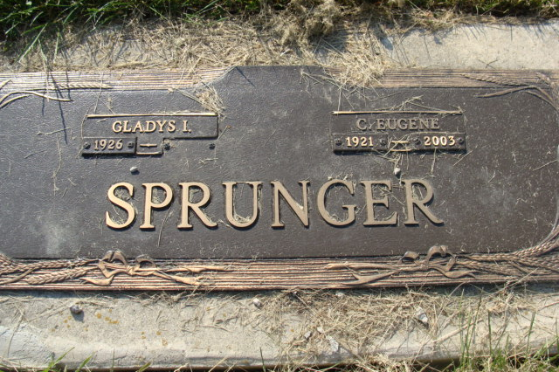
Photo by Alicia Kneuss

Gladys I. Sprunger, 88, Berne passed away on December 24, 2014 at Swiss Village where she was a resident. She was born in Inman, Kansas on October 31, 1926, the third of four children to John P. and Ada (Showalter) Zimmerman. She grew up in Inman, attended Hesston College and Goshen College and earned an elementary teaching degree. She met her husband, C. Eugene Sprunger, while visiting a roommate in Berne. They were later married in 1951. They reared 5 children, Dianne (Lowell) Birkey of Des Moines, IA., Denise (Brian) Fry of Phoenix, AZ., Deb Martens of Berne, IN., Dean (Patty) Sprunger of Syracuse, IN., and Dale (Charisse) Sprunger of Inman, KS.
Gladys was a teacher most of her life between her own children and her classroom students. She retired from Harrison Elementary School in Bluffton, IN. in 1983. After their teaching years, Gladys and Eugene served as missionaries for 2 years with Mennonite Central Committee in Zimbabwe, Africa, helping with agriculture and self supporting work for women. Upon returning to the states, they also hosted exchange students from around the world. Gladys and Eugene were members of the First Mennonite Church and participated with the Intergenerational Sunday School Class.
She has been ill with Alzheimer's for a long time and is happily rejoicing her release into the loving arms of Jesus. Her memorial service will be January 3, 2015 at 10:00 a.m. at the Swiss Village Chapel.
Preferred memorials may be given in her honor to Mennonite Central Committee.

Yager-Kirchhofer Funeral Home, Adams County, Indiana
December 26, 2014

