Gerhart E. Sprunger
July 6, 1905 – January 9, 1960

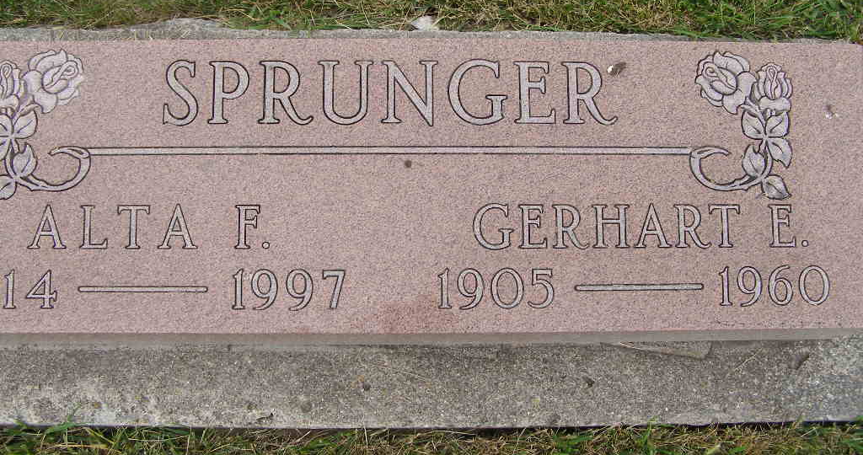
Photo by Shaunda Bedwell Opdycke

Handwritten-Mon. Jan. 11, 1960
Rites for Live Steam Victim Set Tuesday
Funeral services for Gerhart Sprunger, 54, 1002 Nuttman Ave., who was killed Saturday in a boiler accident, will be at 10:30 a.m. Tuesday at the First Mennonite Church in Berne. The Rev. Cornelius Vlot will officiate at the services and interment will follow in the MRE Cemetery.
Sprunger was killed when he was covered with live steam after a boiler plug ruptured at Central Dairy Inc., 2715 Brooklyn Ave. Allen County Coroner Dr. Edgar N. Mendenhall ruled the death accidental and said death was due to asphyxiation, probably by the steam. Sprunger was badly burned about the face, neck and arms, he said.
Sprunger, a boiler engineer at the dairy for 19 years, was alone in the boiler room and he was believed to have been tightening the plug when it gave. The body was found on the floor in front of a large overhead door, directly beneath a suspended electrical conduit. The conduit runs close to the platform eight feet off the floor, on which Sprunger would have been standing where he working on the plug.
It was believed he may have leaped to the conduit in an attempt to escape the scalding steam.
He is survived by his wife, Alta; a daughter, Cheryl, at home; four brothers, Philemon, Chicago; Martin, Decatur; Simeon, Walkerton, Ind.; and Albert, Monticello; and four sisters, Misses Emma and Selma Sprunger, both of Huntington Park, Calif.; Miss Elvina Sprunger, Berne and Mrs. Herman Hirschy, also of Berne.
The body was taken to the Klaehn Funeral Home where friends may call until 10 pm. today.
Adams County, Indiana Historical Museum
Jan1958-Dec1960 Scrapbook, Image 24

