George Sprunger
October 4, 1889 – June 28, 1954

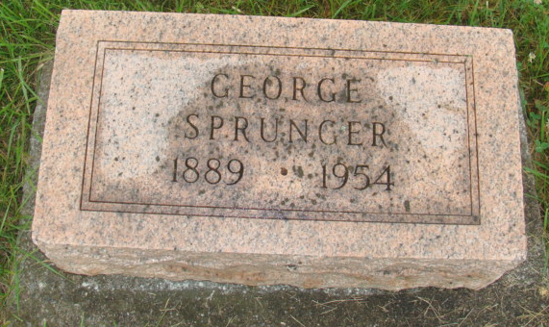
Photo by Alicia Kneuss

Indiana, U.S., Death Certificates, 1899-2017

Name George Sprunger
Gender Male
Race White
Marital Status Married
Age 69
Birth Date 4 Oct 1889
Birth Place Indiana
Death Date 28 Jun 1954
Death Place Fort Wayne, Allen, Indiana, USA
Death Registration Date 1954
Father Joshewn Sprunger
Mother Elizabeth Habegger
Informant Carrie Sprunger, Ft. Wayne, IN
Burial 7-1-1954 M.R.E.
**

Ohio, U.S., County Marriage Records, 1774-1993
Name George Springer
Gender Male
Marriage Age 24
Birth Date abt 1889
Marriage Date 9 Nov 1913
Marriage Place Wayne, Ohio, USA
Father C. Springer
Mother Elizabeth Hapetger..
Spouse Carrie Badertscher
Film Number 000425761

