Friederich Sprunger
April 21, 1849 – April 10, 1914

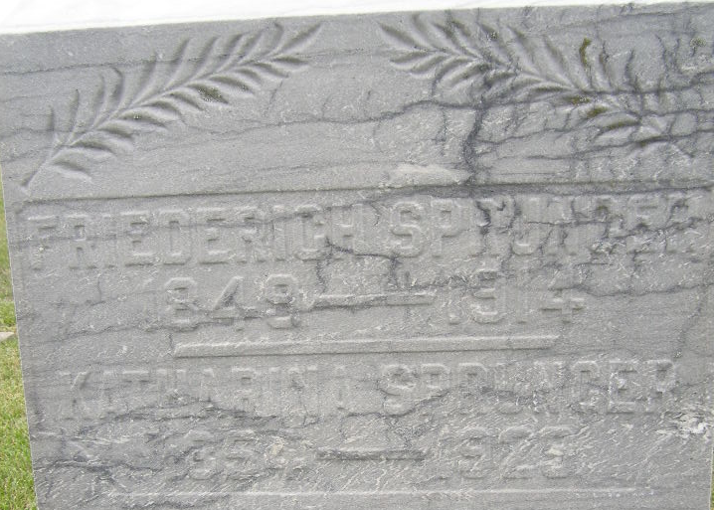
Photo by Shaunda Bedwell Opdycke

Indiana, U.S., Death Certificates, 1899-2017

Name Frederick Sprunger
Gender Male
Race White
Marital Status Married
Age 60y 11m 9d
Birth Date 21 Apr 1849
Birth Place Switzerland
Death Date 10 Apr 1914
Death Place Monroe, Adams, Indiana, USA
Death Registration Date 1910-1919
Father Abraham B Sprunger b. Switzerland
Mother Catherine Sprunger b. Ohio
Spouse Catherine Sprunger
Informant Daniel Sprunger, Berne, IN
Burial MRE 4-13-1914

