Frieda (Neuhauser) Sprunger
May 19, 1896 – May 10, 1948

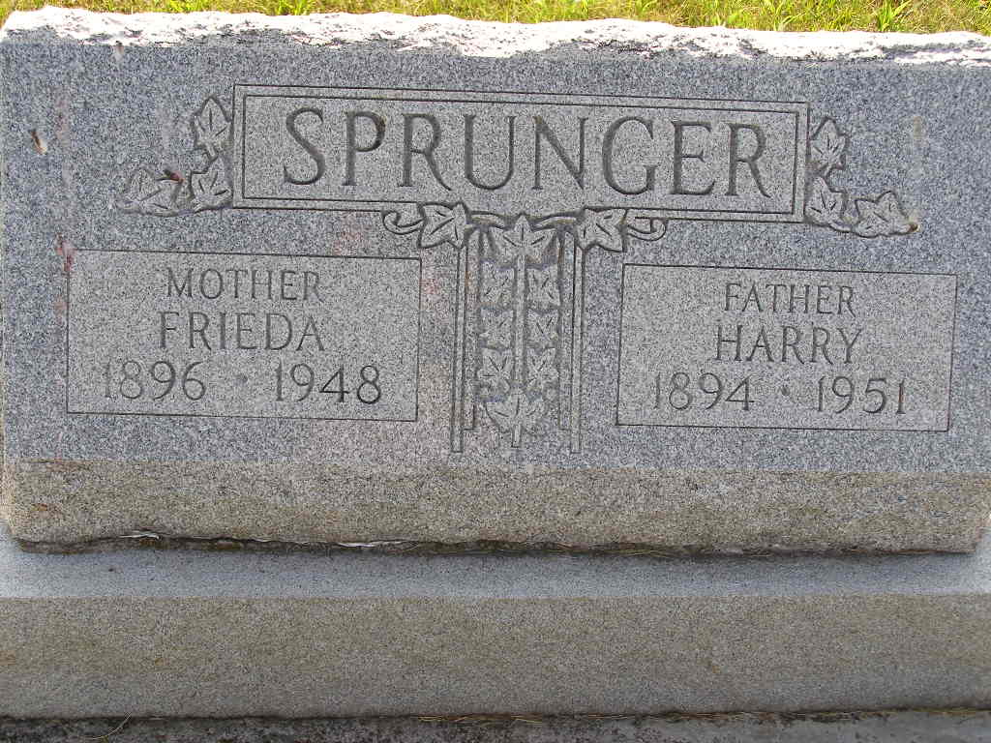
Photo by Shaunda Bedwell Opdycke

Indiana, U.S., Death Certificates, 1899-2017

Name Mrs Frieda Neuhauser Sprunger
[Mrs Frieda Neuhauser Neuhauser]
Gender Female
Race White
Age 51
Marital Status Married
Birth Date 19 May 1897 (sic)
Birth Place Adams County, Indiana
Death Date 10 May 1948
Death Place Berne, Adams, Indiana, USA
Father Jacob Neuhauser
Mother Rosana Steiner
Spouse Harry Sprunger; age 52
Informant: Harry Sprunger; Berne, Indiana
Burial: May 12, 1948; MRE Cemetery; Berne, Indiana
**

Indiana, U.S., Marriages, 1810-2001

Name Frieda Neuhauser
Gender Female
Race White
Age 25
Birth Date 19 May 1896
Birth Place French Twp, Adams, Indiana
Marriage Date 24 Mar 1921
Marriage Place Blank, Indiana, United States
Residence Place Berne, Adams, Indiana
Father Jacob Neuhauser
Mother Rosanna Heiner
Spouse Harry Sprunger
Page 282
FHL Film Number 002321630

