Frieda (Brewster) Sprunger
August 10, 1904 – July 5, 1931

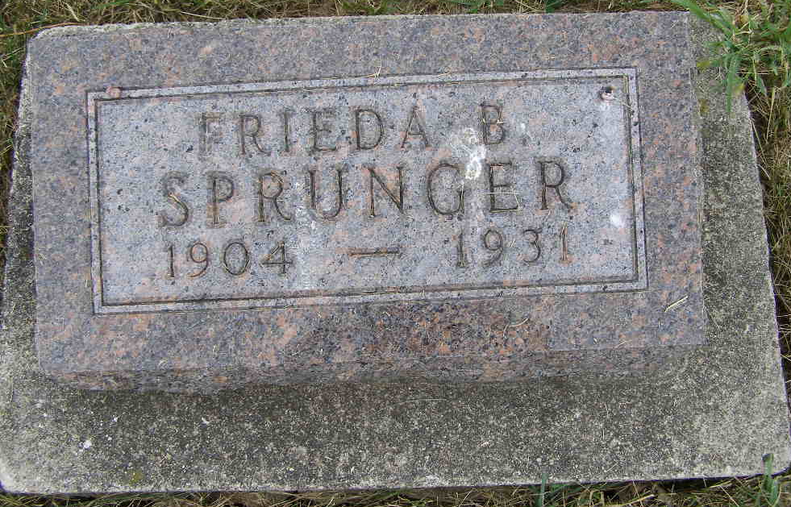
Photo by Shaunda Bedwell Opdycke

APOPLEXY TAKES LIFE OF YOUNG MOTHER
Funeral of Mrs. Willis E. Sprunger Held at Mennonite Church at Berne

Funeral services for the late Mrs. Frieda Brewster Sprunger, wife of Willis E. Sprunger of 328 West Fourth street, Auburn, were held Tuesday afternoon at Berne, in the Mennonite church, with burial in the M. R. E. cemetery at Berne.
The young wife and mother died Sunday morning at 10:45 after an illness of fifteen days. Taken with a nervous breakdown, a clot formed at the base of the brain, causing apoplexy.
She was born August 10, 1904, in Jefferson township, Adams county. She was married April 16, 1922, and was the mother of two children, on of whom is deceased.
Mr. and Mrs. Sprunger have resided in Auburn three years, the husband conducting an upholstering shop on East ninth street.
Surviving are the husband, an 8-year-old daughter, Laverda Louise, and a sister, Florence Lucille Brewster, 12, whom Mr. and Mrs. Sprunger adopted. Also surviving are the father, C. W. Brewster of Fort Wayne, and the following brothers and sisters: Harold Brewster and Mainard Brewster, residing in Auburn, Melvin Brewster of Fort Wayne, Rober Brewster of Decatur, Jean Brewster of Fort Wayne, Hulda Brewster of Berne, and Mrs. Faye Gunder of Decatur.
Mrs. Sprunger was a member of the Blue Creek Methodist church in Adams county.

Garrett Clipper, DeKalb County, Indiana
Thursday, July 9, 1931
**

Indiana, U.S., Death Certificates, 1899-2017

Name Frieda O. Sprunger
Gender Female
Race White
Marital Status Married
Age 26y 10m 25d
Birth Date 10 Aug 1904
Birth Place Indiana
Death Date 5 Jul 1931
Death Place Auburn, DeKalb, Indiana, USA
Death Registration Date 1931
Father C W Brewster
Mother Maud Marsh
Spouse Willis E. Sprunger, informant
Burial MRE 7-7-1931

