Frank Sprunger
February 12, 1902 – January 27, 1988

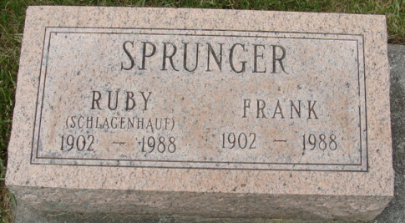
Photo by Alicia Kneuss

Frank Sprunger, 85, died at 7:45 pm Wednesday at Jay County Hospital, Portland. He retired from Central Soya and General Electric, Decatur. His wife, Ruby, died Jan. 10.
Surviving are a daughter, Julia Emick of Seattle, Wash.; a sister; four grandchildren.
No services or calling. Arrangements by Yager-Kirchhofer Funeral Home.

Journal-Gazette, Allen County, Indiana
January 29, 1988
Page 2C
**

Indiana, U.S., Death Certificates, 1899-2017

Name Frank Sprunger
Gender Male
Race White
Marital Status Widowed
Age 85
Birth Date 12 Feb 1902
Birth Place Adams County, Indiana
Death Date 27 Jan 1988
Death Place Portland, Jay, Indiana, USA
Death Registration Date 1988
Father Lewis Sprunger
Mother Mahalia Schenbeck
Informant Charles Isch, Admin., First Bank of Berne
Disposition 2/8/1988 Kleahn Crematory

