Frances Naomi “Betty” (Myers) Sprunger
January 28, 1921 – March 2, 2011

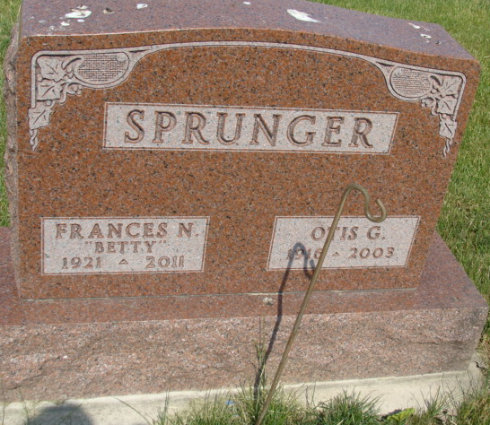
Photo by Alicia Kneuss

Frances “Betty” Sprunger, 90, a resident of Berne, Indiana passed away at 7:45 a.m. Wednesday, March 2, 2011 at the Swiss Village Retirement Community in Berne. Betty was born on January 28, 1921 in Van Wert, Ohio the daughter of Fred and Mary (Teeple) Myers both deceased. She married Otis Sprunger on February 29, 1940 in Willshire, Ohio. He preceded her in death in 2003.
Betty was a member of the First Mennonite Church in Berne. She was a Children’s Sunday School Teacher and a member of Women in Missions. Betty enjoyed quilting and sewing.
Betty is survived by a son, Judson (Margaret) Sprunger of Berne; a son, Jay Sprunger of Berne; a son, Clifton (Susan) Sprunger of Berne; a son, Arnie (Janet) Sprunger of St. Louis, Missouri; a son, Douglas (Dianne) Sprunger of Muncie, Indiana; a daughter, Alice (Marion) Krehbiel of Pretty Prairie, Kansas; a brother, James Myers of Decatur; a sister, Mary Lou Haggard of Portland; fourteen grandchildren, and nine great grandchildren.
Betty was preceded in death by brothers; Guy Myers, John Myers, Fred Myers, and sisters; Ruth Hirschy and Delsen Brehm.
Funeral services will held at 10:30 a.m. Wednesday, March 9, 2011 at the Swiss Village Chapel with the Pastors Keith Rupp and Jerry Flueckiger officiating. Interment will be in the M.R.E. Cemetery of rural Berne. Family and friends will be received from 2:00 – 8:00 p.m. Tuesday, March 8, 2011 at Swiss Village and one hour prior to the funeral service at Swiss Village on Wednesday.
Preferred memorials are to the First Mennonite Church or Swiss Village.

Yager-Kirchhofer Funeral Home, Adams County, Indiana

