Forrest W. Sprunger
December 4, 1925 – September 29, 1994

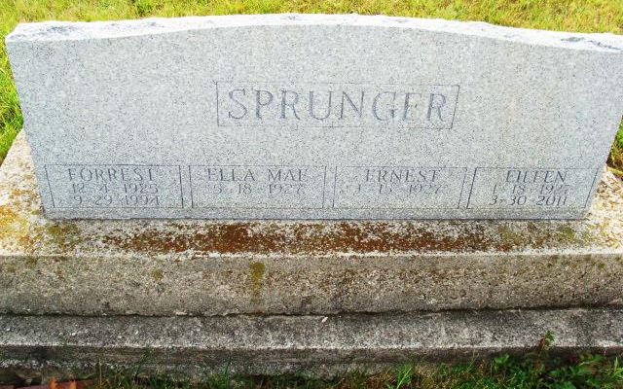
Photo by Alicia Kneuss

FORREST W. SPRUNGER, 68, of Berne died Thursday in South Adams Elementary School, Berne. He was a bus driver and custodian for South Adams Schools for 28 years. He had been a bus driver for Adams Central Schools for 20 years.
Surviving are his wife, Ella Mae; a daughter, Barbara Jane Sprunger of rural Berne; sons, J.W. Sprunger of Scottsdale, Pa., Norman J.D. Sprunger of rural Berne and James E. Sprunger of Goshen; a sister, Dorothy Lehman of Berne; and three grandchildren.
Services are 2 p.m. tomorrow in First Mennonite Church. Calling is from 2 to 9 p.m. today, and from 11 a.m. to 12:30 p.m. tomorrow in the Yager- Kirchhofer Funeral Home, Berne, and from 1 to 2 p.m. tomorrow in the church. Burial will be in M.R.E. Cemetery, Berne. Preferred memorials are gifts to First Mennonite Church or Gideons International.

News-Sentinel, The (Allen County, Indiana)
Saturday, October 1, 1994

