Florine N. (Augsburger) Sprunger
December 29, 1909 – March 2, 2002

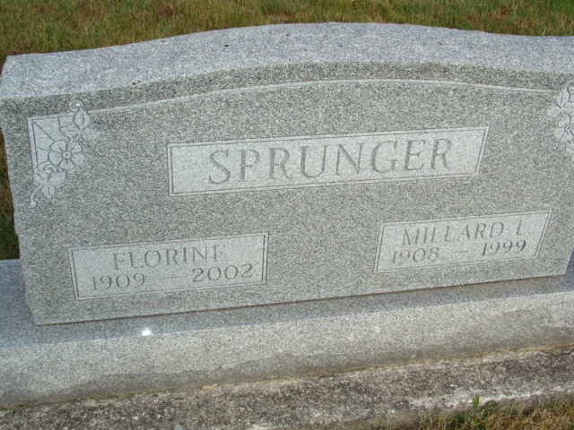
Photo by Alicia Kneuss

Florine N. Sprunger, 92

MUNCIE – Florine N. Sprunger, 92, sister of Muncie resident Ken Augsburger, died Saturday in Berne. She was a homemaker and a member of Grace Bible Church, Berne.
Survivors: son, Lynn Sprunger, daughters, Arlene Huffman, Jean Sprunger; brother, Clyde Augsburger; 11 grandchildren; 17 great-grandchildren.
Services: 2 p.m. Tuesday Grace Bible Church, Berne.
Burial: MRE Cemetery, Berne
Calling: 3-8 p.m. today, Yager-Kirchhofer Funeral Home, Berne, and 1 hour before services Tuesday at the church.
Memorials: ABWE Missions or Native American Missions.

The Star Press, Muncie, Indiana
Monday, March 4, 2002
**

Florine N. Sprunger, 92, of Berne, a member of Grace Bible Church, died Saturday, March 2, 2002, at Swiss Village Nursing Home. The Adams County native was a homemaker. Surviving are a son, Lynn W. of Berne; daughters Arlene R. Huffman of Fort Wayne, and Jean M. Sprunger of Berne; brothers Ken Augsburger of Muncie, and Clyde Augsburger of Berne; 11 grandchildren; and 17 great-grandchildren. She was preceded in death by her husband, Millard; and two sisters. Services are 2 p.m. today at Grace Bible Church, Berne, with calling one hour before services. Burial will be at MRE Cemetery, Berne. Memorials are to A.B.W.E. Missions or Native American Missions. Information provided by Yager-Kirchhofer Funeral Home, Berne, 1-260-589-3101.

News-Sentinel, The (Allen County, Indiana)
Tuesday, March 5, 2002

