Florence Mae (Grime) Sprunger
May 16, 1893 – November 23, 1980

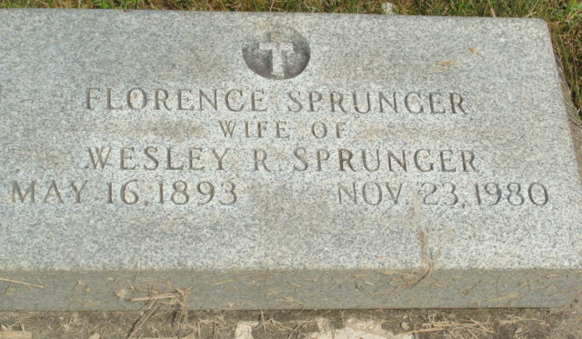
Photo by Alicia Kneuss

Indiana, U.S., Death Certificates, 1899-2017

Name Florence Sprunger
[Florence Grime]
Gender Female
Race White
Marital Status Widowed
Age 87
Birth Date 16 May 1893
Birth Place Ohio
Death Date 23 Nov 1980
Death Place Fort Wayne, Allen, Indiana, USA
Death Registration Date 1980
Father Val Grime
Mother Frana Miller
Informant Kent Sprunger
Burial MRE Cemetery 11/26/1980

