Ferdinand Sprunger
January 27, 1883 – October 8, 1889

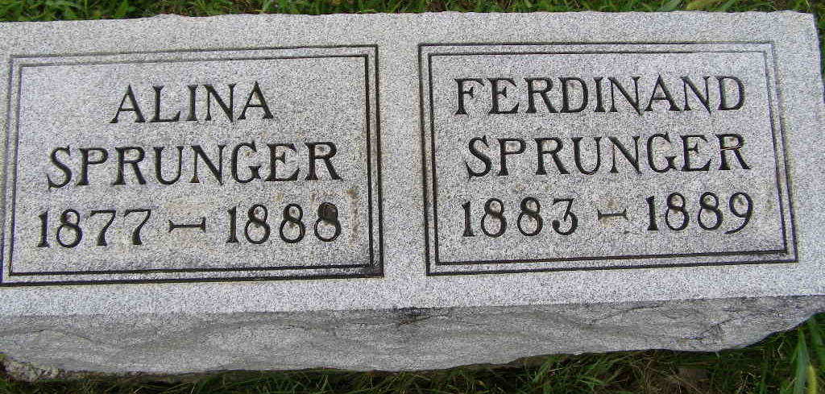
Photo by Shaunda Bedwell Opdycke

Ferdinand Sprunger from tree Holzapfel/Kohli Family Tree

Birth 27 Jan 1883 Indiana, USA
Death 8 Oct 1889 Indiana, USA
Father Abraham A Sprunger (1841-1906)
Mother Magdalina (Maddie) Neuenschwander (1855-1931)
769 People 0 Records 3 Sources
**

U.S., Family History Books

Name Ferdinand Sprunger
Title The Sprunger Family, Descendants of Peter Sprunger, Born 1757, Including His Male Ancestral Line to Hans Sprunger, Born 1565-1575
Author Herr, Willis Eldon
2.3.2.9 Ferdinand Sprunger 1/27/1883 - 10/8/1889 (p. 66)
2.3.2 Abraham A. Sprunger 2/22/1841 - 9-24-1906 (p. 64)
Spouses: Anna Sprunger on 11/22/1862
widow Maria Moser
Magdalina Neuenschwander on 5/3/1873
Abraham lived in Adams Co., Ind. and was a farmer but for many years was connected with cattle breeding and the lumber trade. He was also bank president.

