Fenton Sprunger
January 29, 1898 – December 25, 1983

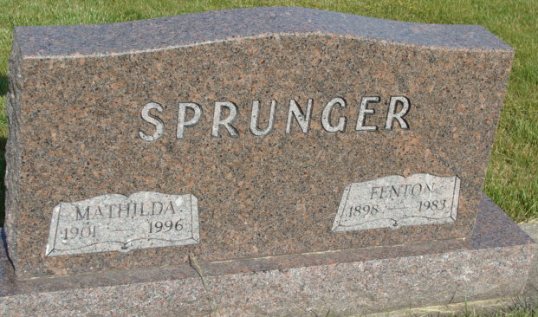
Photo by Alicia Kneuss

Indiana, U.S., Death Certificates, 1899-2017

Name Fenton Sprunger
Gender Male
Race White
Marital Status Married
Age 85
Birth Date 29 Jan 1898
Birth Place Indiana
Death Date 25 Dec 1983
Death Place Decatur, Adams, Indiana, USA
Death Registration Date 1983
Father Silas Sprunger
Mother Rosina Reiff
Spouse Mathilda (Felber) Sprunger, informant
Burial M.R.E. Cemetery 12/28/1983

