Esther (Sprunger) Sprunger
April 14, 1887 – April 3, 1951

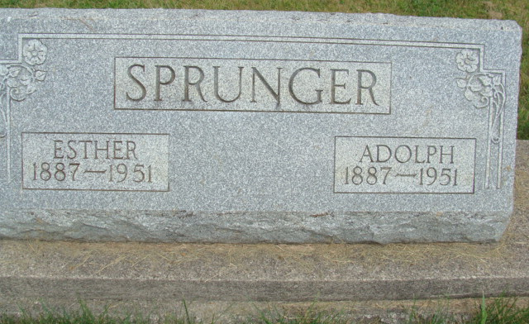
Photo by Alicia Kneuss

Indiana, U.S., Death Certificates, 1899-2017

Name Esther Sprunger
Gender Female
Race White
Marital Status Married
Age 65y 11m 19d
Birth Date 14 Apr 1887
Birth Place Monroe Township, Adams County, Indiana
Death Date 3 Apr 1951
Death Place Rural, Adams, Indiana, USA
Death Registration Date 1951
Father David Sprunger
Mother Regina Moser
Informant Adolph Sprunger
Burial 4-5-1951 M.R.E. Cemetery

