Ernestine E. (Liechty) Sprunger
September 19, 1915 – December 26, 2001

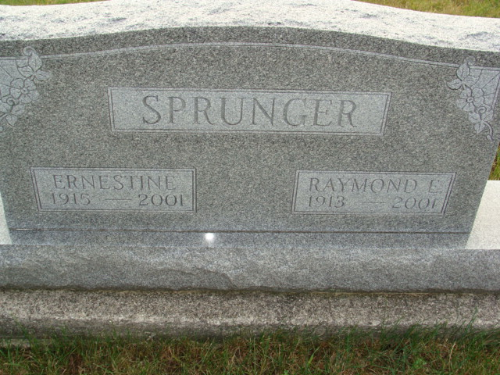
Photo by Alicia Kneuss

Ernestine E. Sprunger, 86, of Berne, who belonged to Grace Bible Church, died Wednesday, Dec. 26, 2001, at Adams County Memorial Hospital. Before her retirement, the Adams County native worked for Berne Apparel. She also worked for the Custom Floor & Wall Drapery Department for 18 years and was a church custodian for 20 years. She belonged to the Ladies' Missionary Society and the church choir. She taught Sunday school at the church.
Surviving is a daughter, Sherryll A. Sprunger of Berne. Her husband, Raymond, died July 30.
Services are 10:30 a.m. Saturday at the church, where calling begins at 9:30 a.m. Calling also is from 3 to 8 p.m. today at Swiss Village Chapel. Burial will be at MRE Cemetery, Berne. Memorials are to the church, Missions to the Americas (the Rev. Paul Biggers) or Gideons International. Information provided by Yager-Kirchhofer Funeral Home, Berne.
News-Sentinel, The (Allen County, Indiana)
Friday, December 28, 2001

