Emma R. (Hofstetter) Sprunger
April 1, 1894 – September 6, 1955

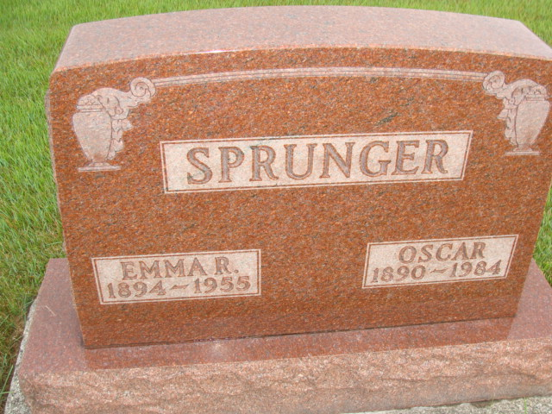
Photo by Alicia Kneuss

Handwritten-Wed. Sept. 7, 1955

WIFE OF OSCAR SPRUNGER DIES AT HOME HERE
Hodgkin's Disease Fatal; Funeral Thursday Afternoon

Mrs. Emma Hofstetter Sprunger, 61, wife of Oscar Sprunger, died at 2:15 a.m. Tuesday at her home at 663 Fulton Street. Death followed an illness of six months. She had been bedfast four months and critically ill the past few weeks. The attending physician announced the cause of death as Hodgkin's disease.
Mrs. Sprunger was born at Fortuna, Mo., April 1, 1894, the daughter of William and Caroline Lehman Hofstetter. She was a resident of Adams County for the last 39 years. She was married to Oscar Sprunger July 27, 1930, at the parsonage of the local First Mennonite Church.
Surviving in addition to the husband are a son, Omer, at home; two daughters, Claranell Sprunger at home and Mrs. Larry (Lucinla) Coblentz, San Diego, California; five brothers, Ernest Hofstetter, California, Mo.; Elvin Hofstetter, Fortuna, Mo.; Harvey Hofstetter, and Ira Hofstetter, both of California, Mo.; and William H. Hofstetter, St. Louis, Mo., and three sisters, Mrs. Aubrey Tryse, California, Mo.; Mrs. Carl Hohmann, Deer Creek, Okla;, and Mrs. William Friedrick, Kansas City, Mo.
The body is at the Yager Funeral Home where friends may call. Services will be held at 2:00 p.m. Thursday at the First Mennonite Church of which she was a member, Howard Habegger assistant pastor of the church officiating in the absence of Rev. O. A. Krehbiel, the pastor. Burial will be in the M.R.E. Cemetery.

Adams County (IN) Historical Museum
1955 March-April 1958 Scrapbook, image 27

