Emil A. Sprunger
July 27, 1881 – February 28, 1944

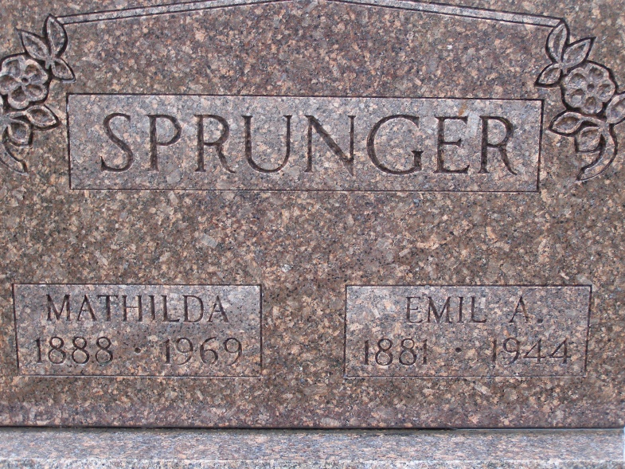
Photo by Shaunda Bedwell Opdycke

Indiana, U.S., Death Certificates, 1899-2017

Name Emil A Sprunger
Gender Male
Race White
Marital Status Married
Age 62y 7m 1d
Birth Date 27 Jul 1881
Birth Place Berne, Adams, Indiana
Death Date 28 Feb 1944
Death Place Berne, Adams, Indiana, USA
Death Registration Date 1944
Father Simeon Sprunger
Mother Emma Huser
Spouse Mathilda Hirschy Sprunger, age 55
Informant Mrs. Emil Sprunger
Burial MRE 3/2/1944
**

SONS IN SERVICE GET WORD OF FATHER'S DEATH

Word has been received from both Melvin and Tilman Sprunger, by their mother, Mrs. E. Sprunger, stating that they had received word of their father's recent death. Both young men are serving overseas, Melvin, in the Italian War Theatre and Tilman in the South Pacific. Melvin states that he received sympathy cards from friends a day before the message of his father's death reached him.

Adams County, Indiana Historical Museum
1944 Jan-Oct Scrapbook

