Emanuel Sprunger
November 18, 1854 – August 5, 1936

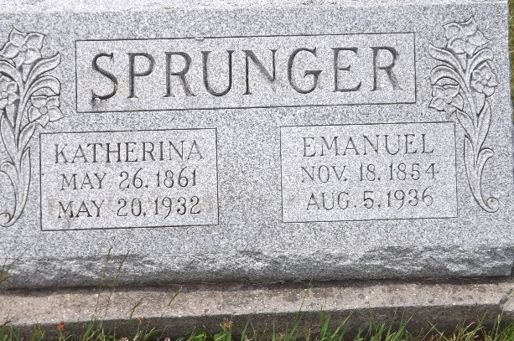
Photo by Jim Allen

AGED RETIRED FARMER DIES AT HOME HERE
Emanuel Sprunger, 81 Dies; Funeral is Saturday Afternoon

Emanuel Sprunger, aged 81, prominent retired farmer, died shortly before 4 o’clock Wednesday afternoon at his home on North Sprunger street. Death was caused by uremia and complications. A post mortem was held to determine the cause of death. Mr. Sprunger had been bedfast for two weeks. Previous to that time he was able to come uptown, although he had been in failing health for some time. He suffered from kidney (?) at various times. Sunday he suffered chills and since then his condition was critical and he weakened rapidly. Mr. Sprunger was unconscious several hours before his demise and passed away quietly.
Mr. Sprunger was born in what is now the Berne corporation limits, he is said to have been the first child born here. He was a son of Peter and Marianna Moser Sprunger and was born Nov. 18, 1854. Both father and mother came here from Switzerland in the pioneer days of 1852. Mr. Sprunger was married to (?) Stauffer, Dec. 5, 1880. On the same date in 1930 the couple celebrated their golden wedding anniversary. Mrs. Sprunger passed away May 20, 1932.
(?) his marriage, Mr. Sprunger was a prominent carpenter and built many of the early homes. He was also a prominent farmer (?) years, residing one and one-half miles north of Berne, on the farm where Rufus Sprunger now lives, (?) years ago he and his wife moved to Berne.
Surviving are the following children: Rufus, Adolph and (?) Sprunger, all of north of town; Caleb (?) Sprunger of Berne, and Zilla and Arley (?) of Berne. Nineteen grandchildren, (?), two great-grandchildren . Brothers and sisters surviving: C.C. and Benjamin Sprunger, Emanuel Liechty and Mrs. (?) Stucky. Two brothers (?) Daniel are deceased….cut off (PHOTO PROVIDED)

Adams County (IN) Historical Museum
1936 Scrapbook, image 104
dated Thursday, August 6, 1936
**

Indiana, U.S., Death Certificates, 1899-2017

Name Emanuel Springer
Race White
Marital Status Widowed
Age 81y 8m 17d
Birth Date 18 Nov 1854
Birth Place Indiana
Death Date 5 Aug 1936
Death Place Berne, Adams, Indiana, USA
Father Peter Sprunger b. Switzerland
Mother Mary Ann Moser b. Switzerland
Informant Rufus Sprunger, Berne, IN
Burial MRE Cem. 8-8-1936
**

U.S., Family History Books

Name Emanuel Sprunger
Gender Male
Birth Date 18 Nov 1854
Birth Place Adams County Indiana
Marriage Date 5 Dec 1880
Spouse Katharina Stauffer
Title The Sprunger Family, 1757-1972: in Three Parts From Manuscripts
p. 62 #26 Emanuel Sprunger, born November 18, 1854, Adams County, Indiana, married December 5, 1880 to Katharina Stauffer, daughter of Christian Stauffer. They lived in Berne, Indiana. He was a carpenter and room finisher.
Children Aldina b. December 5, 1881
Rufus b. March 19, 1883
Ottilie b. August 23, 1885
Zilla b. December 27, 1889

