Elwin Lee Sprunger
December 10, 1927 – December 10, 1927

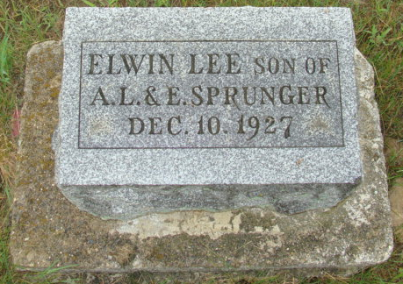
Photo by Alicia Kneuss

Indiana, U.S., Death Certificates, 1899-2017

Name Elwin Lee Sprunger
[Elwin Lee Lee]
Gender Male
Race White
Marital Status Single
Age 4hrs 15min, premature birth
Birth Date 10 Dec 1927
Birth Place Fort Wayne, Indiana
Death Date 10 Dec 1927
Death Place Fort Wayne, Allen, Indiana, USA
Death Registration Date 1926-1927
Father Alfred L. Sprunger, informant
Mother Ella Sprunger
Burial Berne, Indiana 12/11/1927

