Elvina Anna Sprunger
November 24, 1897 – February 13, 1987

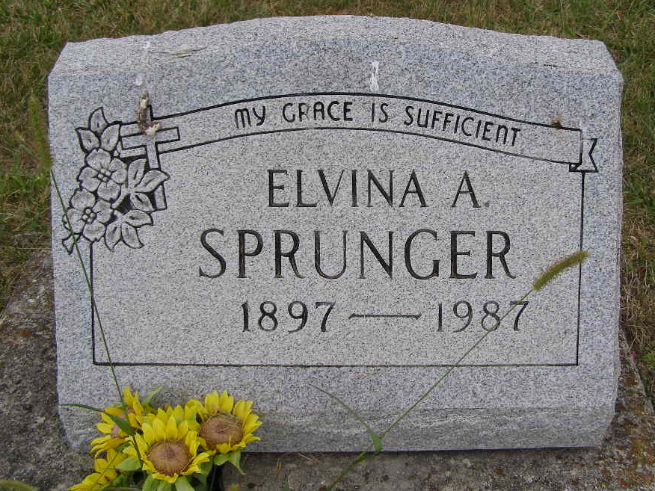
Photo by Shaunda Bedwell Opdycke

Indiana, U.S., Death Certificates, 1899-2017

Name Elvina A Sprunger
Gender Female
Race White
Marital Status Never Married (Single)
Age 88
Birth Date 24 Nov Abt 1898
Birth Place Indiana
Death Date 13 Feb 1987
Death Place Berne, Adams, Indiana, USA
Death Registration Date 1987
Father Simeon Sprunger
Mother Rachal Sprunger
Informant Laura Hirschy, Niece
Burial M.R.E. 2/16/1987
**

Elvina Anna Sprunger from tree Häring 2024

Birth 24 Nov 1897 Adams, Indiana, USA
Residence 1950 Berne, Adams, Indiana, USA
Death 13 Feb 1987 Berne, Adams, Indiana, USA
Father Simeon Daniel Sprunger (1859-1941)
Mother Rachel R. Sprunger (1859-1924)
83260 People 3 Records 8 Sources

