Elma O. (Welty) Sprunger
December 6, 1881 – March 2, 1961

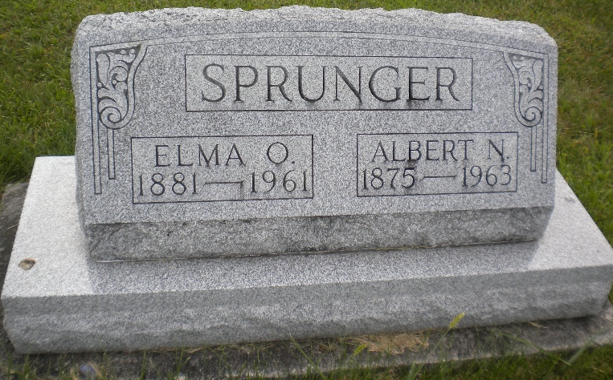
Photo by DSON1492

Wife Of Albert Sprunger Dies Early Thursday
Funeral Here Saturday For Local Woman, 79
Mrs. Elma Welty Sprunger, 79, wife of Albert N. Sprunger of this city, died at 1:15 a.m. Thursday at the Adams County Memorial Hospital. Death was attributed to a coronary occlusion. Mrs. Sprunger was in the hospital six weeks and had ailed for a longer period. Her condition was critical the last few days.
A resident of this community since 1904, Mrs. Sprunger was a native of Fortuna, Mo., where she was born Dec. 6, 1881, the daughter of John B. And Rose Lehman Welty. She was married to Albert N. Sprunger, October 14, 1907, in Berne by the Rev. J.W. Kliewer. Her husband, who is in the Berne Nursing Home, was a prominent business man in Berne for many years. Mrs. Sprunger was a member of the First Mennonite Church.
Surviving in addition to the husband are a son, Orlando W. Sprunger, Berne R. R. 2; five daughters, Lucretia Sprunger, at home; Mrs. Herman (Celia) Hilty, Bluffton, Ohio R.R.2; Mrs. Leonard (Marguerite) Wiebe, Orosi, California; Mrs. Leland (Winifred) Gerber, Bluffton, Ohio and Mrs. Dwight (Phyllis) Suter, Pandora, Ohio; 18 grandchildren and a sister, Mrs. Harry (Ella) Kohler, Fresno, California. Two brothers and two sisters preceded in death.
The body is at the Yager Funeral Home where friends may call until noon Saturday when it will be taken to The First Mennonite Church where it will lie in state until 2 p.m., when the funeral will be held at the church, Rev. Gordon Neuenschwander officiating. Burial will be in the M.R. E. Cemetery.
Adams County, Indiana Historical Museum
1951Jan-Aug1962 Scrapbook; image 16
Handwritten-Fri. March 3, 1961
**
Berne Lady Dies At Hospital
Funeral services will be held at the First Mennonite Church of Berne for Mrs. Elma O. Sprunger, 79, who died at 1:15 a.m. Thursday at the Adams County Memorial County Hospital. She had been hospitalized six weeks. A native of Missouri, Mrs. Sprunger had resided in Berne since 1904.
Surviving are the husband, Albert N.; one son; five daughters; 18 grandchildren and one sister.
The body is at the Yager Funeral Home where friends may call this evening. Burial will be in the MRE Cemetery.
Adams County, Indiana Historical Museum
1951Jan-Aug1962 Scrapbook; image 17
Handwritten-Fri. March 3, 1961
**
Indiana, Death Certificates, 1899-2011
Name: Elma Sprunger
[Elma Welty]
Gender: Female
Race: White
Age: 79
Marital status: Married
Birth Date: 6 Dec 1881
Birth Place: Fortuna, Missouri
Death Date: 2 Mar 1961
Death Place: Decatur, Adams, Indiana, USA
Father: John B Welty
Mother: Rose Lehman
Spouse: Albert Sprunger, informant
Burial: 3/4/1961 M.R.E. Cemetery

