Elma Corinne Sprunger
March 2, 1892 – March 1983

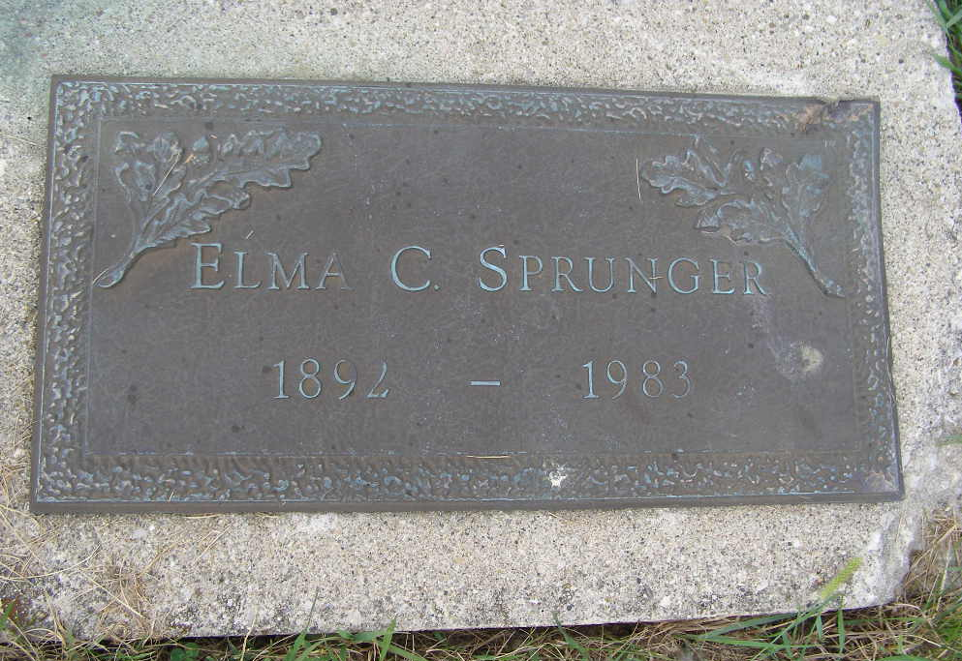
Photo by Shaunda Bedwell Opdycke

Indiana, U.S., Death Certificates, 1899-2017

Name Elma C. Sprunger
Gender Female
Race White
Marital Status Never Married (Single)
Age 91
Birth Date 2 Mar 1892
Birth Place Indiana
Death Date 24 Mar 1983
Death Place Berne, Adams, Indiana, USA
Death Registration Date 1983
Father David C. Sprunger
Mother Verena Sprunger
Informant Mrs. Calvin Nussbaum
Burial MRE 3/26/1983

