Ellis Howard Sprunger
May 15, 1892 – August 24, 1956

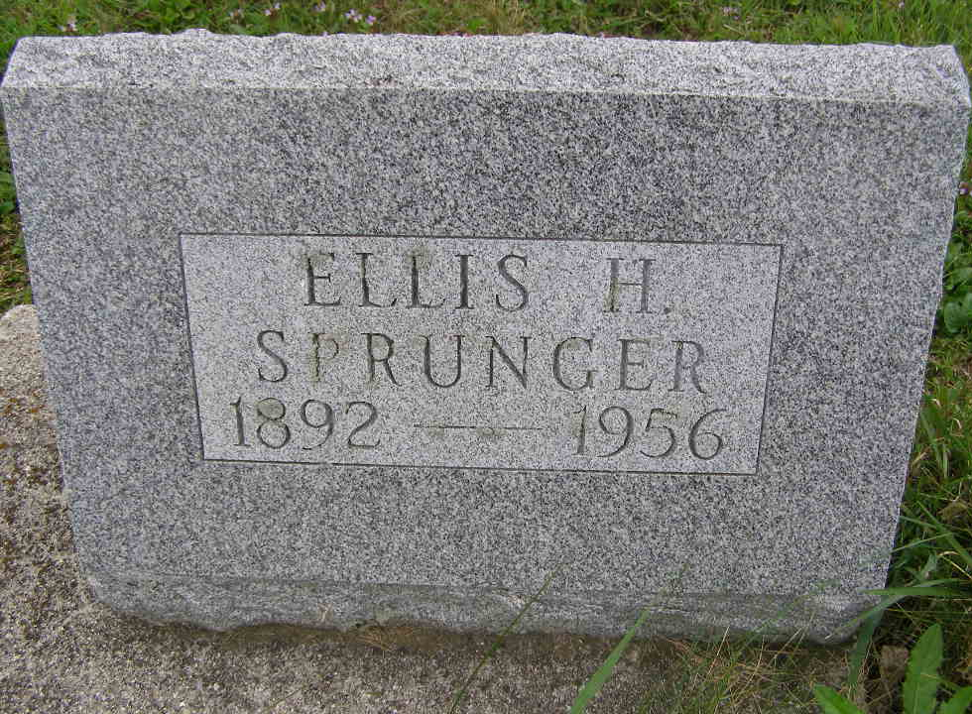
Photo by Shaunda Bedwell Opdycke

Sprunger Burial Here on Thursday
Graveside services will be held at 10:30 a.m. Thursday at the M.R.E. Cemetery west of Berne for Ellis H. Sprunger, 64, of Detroit, who died at a hospital in that city at 11:00 p.m. Sunday after month's illness. The body may be viewed at 10:15 a.m. Thursday at the cemetery. Rev. O. A. Krehbiel will office at the graveside service.
Funeral services were held at 1:00 p.m. today at the William Hamilton Funeral Home in Detroit and the body is being brought here after the service.
Mr. Sprunger was a native of Berne, edited the Berne Witness for two years and was in Y.M.C.A. work for about 30 years.
Ellis H. Sprunger, known by many as Dudley, died in Detroit following an illness of one month. The younger generation here, Mr. Sprunger is not so well known but for a couple years he was editor of the Berne Witness. Later he entered Y.M.C.A. work and had devoted many years of his life as Y.M.CA. membership secretary and the past 11 years was Michigan Y.M.C.A. state secretary. His contributions to the welfare of the young men in the communities where he was located can never be measured. Mr. Sprunger loved this type of work and he was never happier than when with a group of young fellows. Oddly enough it was while seeing a group of boys off for an outing that he became ill. He had planned to retire from this work at the end of June and move with his wife to San Francisco, California, where their only son is with the Associated Press. Dudley will be missed by his family and friends, and to his survivors, we too offer our condolences.
Adams County, Indiana Historical Museum
1955 Mar-April 1958 Scrapbook, Image 51
Handwritten-Wed. July 25, 1956
**

Ohio, U.S., County Marriage Records, 1774-1993

Name Ellis H. Sprunger (indexed as Springer)
Gender Male
Marriage Age 25
Birth Date abt 1892
Marriage Date 12 Jun 1917
Marriage Place Butler, Ohio, USA
Father J. F. Springer
Mother Catherine Nussbaum
Spouse Miss Helen Kennel
Film Number 000355791
**

U.S., Social Security Applications and Claims Index, 1936-2007

Name Ellis H Sprunger
Birth Date 15 May 1892
Death Date 22 Jul 1956
Claim Date 24 Aug 1956
SSN xxx
Notes 19 Jan 1978: Name Listed As Ellis H Sprunger

