Ellen A. (Liddy) Sprunger
September 29, 1886 – August 13, 1964

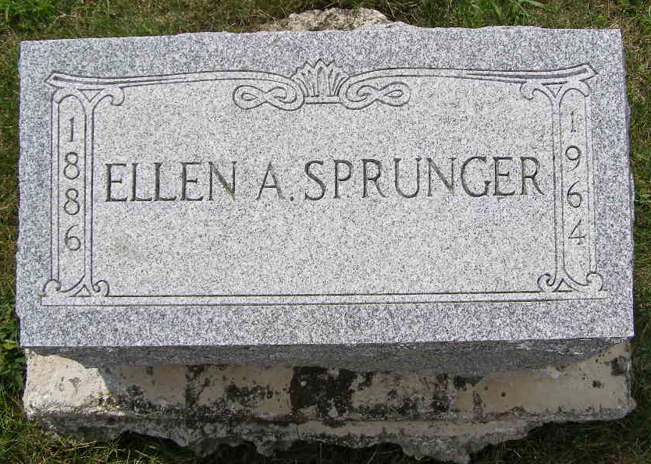
Photo by Shaunda Bedwell Opdycke

Saginaw County, Michigan, U.S., Obituary Index, 1800-2020

Name Ellen A. Sprunger
Maiden Name Liddy
Gender Female
Death Age 77
Birth Date 29 Aug 1886; Birth Place Berne, in
Marriage Date 1905
Arrival in US Saginaw 1917
Death Date 13 Aug 1964; Death Place Saginaw, MI
Burial Church Evangel. (Berne, In)
Burial Information Yager (Berne, In)
Obituary Date 14 Aug 1964
Obituary Place Saginaw, Michigan, USA
Publication Saginaw News
Page number B7
Spouse Henry
Notes Employed At Saginaw General Hospital
**

Indiana, U.S., Marriages, 1810-2001

Name Ella Liddy
Gender Female
Race White
Age 19
Birth Date 29 Sep 1886
Birth Place Linn Grove, Adams, Indiana
Marriage Date 14 Jul 1906
Marriage Place Indiana, United States
Residence Place Berne, Adams, Indiana
Father Joel Liddy
Mother Atlanta Hill
Spouse Henry Sprunger
Officiator David Gerber
Page 258

