Ella (Reusser) Sprunger
April 28, 1878 – October 9, 1931

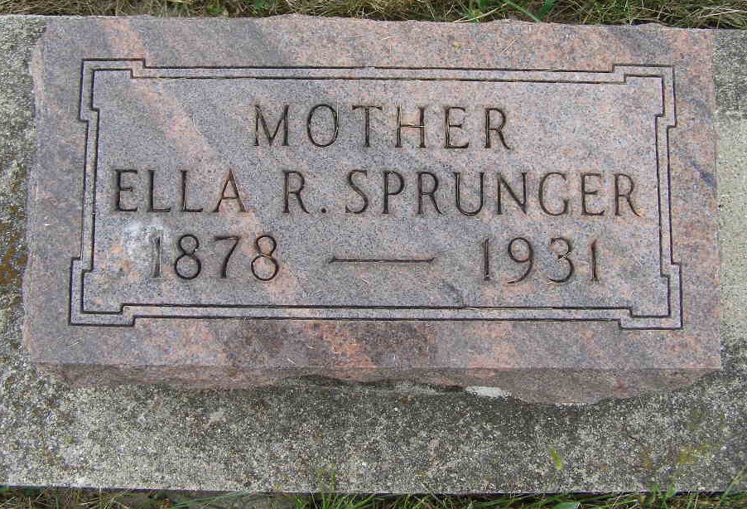
Photo by Shaunda Bedwell Opdycke

Indiana, U.S., Death Certificates, 1899-2017

Name Ella Sprunger
[Ella Reesser]
Gender Female
Race White
Marital Status Married
Age 53y 5m 11d
Birth Date 28 Apr 1878
Birth Place Kansas
Death Date 9 Oct 1931
Death Place Berne, Adams, Indiana, USA
Death Registration Date 1931
Father Christian Reusser
Mother Rebecca Neuenschwander
Spouse D.J. Sprunger, informant
Burial M.R.E. Cemetery 10-12-1931

